JOB DESCRIPTION

Job Title: | Finance Team Leader
Division/Programme  and Section/Project (if any): | Human Rights and Social Development Division (HRSD) and Finance, Operations and Management Directorate (OMD)
Location: | Suva, Fiji
Reporting to: | Matrix Reporting:  Director HRSD (Direct reporting line)  Finance Manager Suva, OMD (Dotted line)
Number of Direct Reports: | Up to 5
Purpose of Role: | The Finance Team Leader is overall responsible for the provision of financial services to the Division’s programmes and projects, and supports the implementation of the shared services vision in the division which supports a new way of working through collaboration between central finance and divisions.
Date: | November 2021

Organizational Context and Organisation Chart

The position of division Finance Team Leader is a key role in the provision of quality finance services to all SPC. The team leader is responsible for ensuring that the benefits and responsibilities related to the shared services way of working are established within the division. This will mean that the division will receive quality finance services while tapping into the broader shared services structure and offerings to ensure divisional programmes are adequately supported.

The Shared Services way of working within SPC is new. The Shared Services way of working aims to bring the expectations of the divisions and corporate or central finance expectations within OMD into alignment, and to build a strong shared services model from which these services may be jointly delivered. It is a significant change project in both culture as well as in the way work is done.

This role will provide finance team leader services to the HRSD division and is a key part of the divisional senior management team. The incumbent may be redeployed to other divisions from time to time as other needs arise.

Under its Business Plan 2021-2025, the vision of the Human Rights and Social Development Division (HRSD) is for just, equitable and resilient Pacific societies. HRSD aims to achieve this vision by advancing human rights, gender equality and social inclusion for all Pacific people, grounded in cultural values and principles.

In line with its vision, the work of the Division encompasses the following objectives:
- Objective 1: Governance for human rights and social development: Strengthen inclusive, transparent and active governance for human rights and social development.
- Objective 2: Gender equality and social inclusion: Mobilise, empower and build conditions for gender equality, equity and social inclusion in society and development.
- Objective 3: Culture: Promote, preserve and protect positive expressions of culture.
- Objective 4: Enhance knowledge, learning and innovative solutions to accelerate impact on human development priorities.
The work programme for HRSD currently includes two large programmes – the PROJECT Governance Initiative and Pacific Women Lead (PWL). PROJECT Governance is a new human rights and good governance programme commencing in 2021 for a period of five years, funded by the United States Government in the amount of USD 19 million. PWL is a new Pacific regional development programme commencing in 2021 for an initial period of five years, funded by the Australian Government in the amount of AUD 57 million. A significant portion of the funding under PROJECT Governance and PWL will be on-granted to implementing partners although HRSD will retain responsibility to the donors for these funds. The Finance Team Leader role will cover all areas of HRSD including PROJECT Governance and the PWL programme.

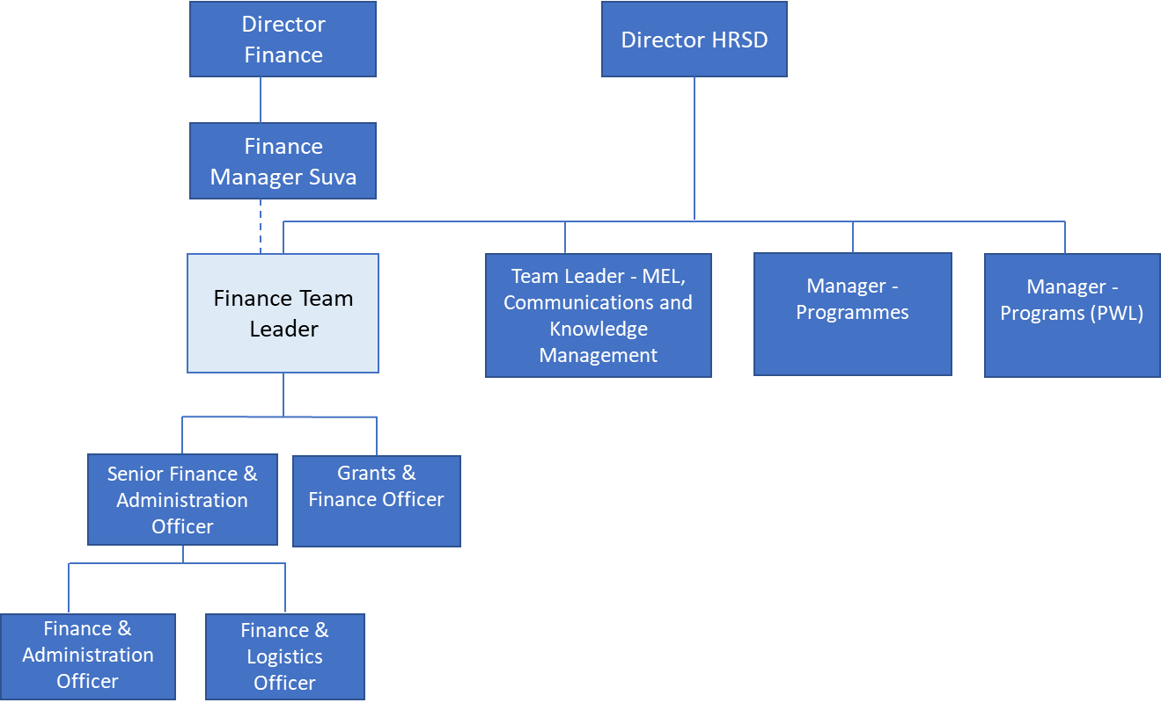

Key Result Areas (KRAs):

The position of Finance Team Leader encompasses the following major functions or Key Result Areas (KRAs):
KRA 1: Shared Services in the division
KRA 2: Financial planning, monitoring and reporting
KRA 3: Divisional, project and programme financial administration support
KRA 4: Compliance, risk management and business processes
KRA 5: Procurement and grant services
KRA 6: People management

The performance requirements of the Key Result Areas are broadly described below

Jobholder is accountable for | Jobholder is successful when
KRA 1 – Shared Services in the division
- Lead the SPC Finance and Procurement shared services agenda within the division in close collaboration with the central finance team. Be responsible for the division’s uptake of the shared services work. This includes  - Work-planning and deployment  - Knowledge sharing, process refinements / reviews and increasing collaboration  - Time-charging  - Conflict resolution and relationships  - Work closely with finance team leaders in other divisions, and in collaboration with the finance managers, to  - Understand and document the key business requirements of Shared Services in divisions.  - Understand the capabilities of existing corporate systems and exploit these to meet the requirements of Shared Services in divisions. Lead or co-lead in designing systems requirements and support corporate development efforts.  - Propose and design a data system and metrics for the collection, collation, reporting and interpretation of shared services data. This includes reporting tools that  - Measure KPIs and SLAs  - Capture and encourage sharing, collaboration, knowledge gathering and learning.  - Manage and forecast workforce needs. | - The shared services vision and agenda is successfully implemented throughout the division.  - Business and data requirements of Shared Services are documented and regularly updated.  - Existing business systems are used to meet Shared Services requirements. New business systems are proposed if necessary.  - Key reports and metric analyses are produced for Shared services.
KRA 2 - Financial planning, monitoring and reporting

- Lead by overseeing the role of finance officers in all aspects of financial management in the division, including budgeting and forecasting, monitoring of project executions, pipeline projects, financial analysis and reporting. The budgeting process might include the development of costed workplans and contain integrated programming considerations. Reporting would include monthly budget versus actuals for the division management team and reporting to donors. Use Power BI in an effective way for high level financial reporting.  - Support audit exercises or due diligence probes led by finance in central, donors, partner organisations or internal auditors where required ensuring maximum level of compliance. Have document management systems and processes are in place to always ensure audit readiness.  - Ensure financial accounting systems for project and operations are maintained, including but not limited to, cash management, project payables and receivables including grants. | - The divisions annual corporate budget process is well managed. Inputs are provided to the finance team in central in a timely manner. The budget accurately reflects the financial outlook for the division.  - High performing budget and report tracking tools are employed to give visibility to results.  - Project workplans are appropriately costed  - Project pipeline is kept up to date  - All audit exercises involving the division occur without incident, documentation is easy to retrieve.  - All cash management, project payables and receivables are accurately reflected in the ledger.
KRA 3 - Divisional, project and programme financial administration support

- Provide appropriate coordinated support to divisional staff, working across programme areas on donor requirements in programme planning, delivery and financial administration of all donor-funded projects. Support technical staff with financial and economic modelling for projects (e.g. cost-benefit analysis) where possible and appropriate. This includes in-country staff.  - Work with finance officers to liaise with project team leaders, development partners and donors to ensure project or division finance and administration staff maintain reporting schedules, financial acquittals and arrange for timely disbursements in accordance with signed funding agreements.  - Liaise with development and implementing partners at planning stage on financial agreements to ensure they meet all SPC financial requirements with supporting documentation.  - Facilitate capacity building programmes for project focal points and beneficiaries on SPC finance and procurement policy requirements and processes, in line with Shared Services programmes such as the peer review programme and centre of excellence. | - Finance staff in division, both core and project funded, feel supported with adequate resources in all financial areas of work, including with specialist support in financial and economic modelling.  - Finance staff in division, both core and project funded, perform consistently in relation to donor requirements and development partner expectations.  - SPC’s financial compliance requirements are understood and accepted by donors and development partners at proposal or negotiation stages of project development.  - Finance and administration staff in division, both core and project funded, are given adequate training in SPC’s policies and guidelines, and participate in any relevant Shared Services programme that encourages knowledge transfer and best practice.
KRA 4 - Compliance, risk management and business processes
- Oversee and ensure appropriate systems and internal controls are implemented. Collaborate with internal stakeholders where instances of internal control weaknesses are found in order to strengthen these. Lead in coordinating action on audit issues pertaining to the division.  - Lead finance’s input to the division’s risk management processes, including in the work-planning process, as it pertains to financial and compliance risk, identifying potential risks, such as, irregular expenditures not approved in work plan  - Lead in the division’s review and implementation of applicable SPC finance policies, as required, including ensuring compliance of the requirements of the policies in the division. | - Recommendations from internal and external audit  - reports to strengthen internal controls are implemented in a timely manner.  - Divisional programme leaders and directors are kept well informed of emerging financial risks to the workplan and provided with advice.  - SPC wide policy, guidelines and process reviews consider the division’s perspective on issues.  - Division project and finance staff are well aware of their responsibilities so far as the finance policies are concerned.
KRA 5 - Procurement and Grant services
- Ensure all procurement and grant processes undertaken by the division are in line with SPC and donor policies and procedures. Work closely with the division grants officer to ensure this occurs.  - Work with the procurement team to facilitate the preparation and monitoring of the Division’s annual procurement plan. Support the corporate SPC annual procurement planning process as required.  - Work with the finance & grants officer and procurement office to monitor key databases and workflows for all procurement and grant activities to ensure efficiency, completeness, availability of up-to-date information, and to allow effective follow-up action.  - Work with the finance & grants officer and procurement office to monitor all procurement and grant actions, including the execution of contracts within the division, in concert with the grants officer. Take remedial action where practices are not in accordance with SPC policies and guidelines. | - Procurement processes run smoothly and are accurately reported with supporting documents, contracts comply with procurement policy and are monitored as per terms of reference.  - Annual Procurement Plan completed at required standard.  - Working with Procurement Office and Finance & Grants officer to ensure timely procurement briefings and appropriate training is provided to staff in division.  - Documentation for submission to Procurement Committee finalised on time and Procurement Committee meetings supported  - Contracts for consultants are managed well for timely delivery of service to the stakeholders.  - Assistance is provided in the preparation of draft LOAs and MOUs with development partners and national stakeholder
KRA 6 - People management
- Creating a team environment that fosters and develops effective working relationships and high performance.  - Manage staff members responsible for the administration, operations and logistics of the Division.  - Manage staff performance and support training and development  - Conduct fair, consistent, timely performance planning and review meetings and encourage open communication to discuss performance.  - Monitor the performance and workloads of staff members to ensure objectives are met.  - Supports the health and safety and well-being of employees in the way they manage and monitor the team | - Mentoring, coaching and guidance is provided to staff on a timely basis.  - The administrative, operational and logistical requirements of the Division are met in a timely manner.  - Financial training on all areas of divisional finance work is provided to staff to ensure compliance with SPC procedures.  - Ensures corporate requirements are met individually and as a team including the performance planning and assessment cycle  - Performance issues are addressed in a timely manner.  - Health and safety risks, issues and hazards are reported and addressed
The above performance requirements are provided as a guide only. The precise performance measures for this job will need further discussion between the jobholder and supervisor as part of the performance development process.

Most Challenging Duties Typically Undertaken (Complexity):

Most challenging duties typically undertaken:
- Being the Shared Services champion in the division when this way of working is still new.
- Providing strong financial management leadership in an uncertain financial environment
- Managing different stakeholder needs and expectations in a changing environment.
- Managing dual or matrix reporting line relationships.
- Actively cultivating and working closely with other finance team leaders horizontally.
- Supporting a diverse group of divisional finance and procurement staff to work together towards attaining the Shared Services vision.
- Promoting the new Shared Services way of working in a traditionally siloed organisation

Functional Relationships & Relationship Skills:

Key internal and/or external contacts | Nature of the contact most typical
External  - Donors  - Consultants  - Grantees  - Member countries  - Auditors  - Regional agencies | - Discuss policies, processes  - Understand expectations  - Obtain advise  - Provide reporting and information
Internal  - Division director and senior staff  - Division finance & procurement staff and PAs  - Finance Managers  - Procurement Manager  - Shared Services Manager | - Discuss issues, resolve issues / conflicts.  - Obtain direction and support.  - Obtain advise and provide advice.  - Facilitate collaboration and sharing.

Level of Delegation:

Overall budget managed by the role: Approximately €12m per annum based on 2022 budget.
Budget sign off authority without requiring approval from direct supervisor: Nil

Personal Specification:

This section is designed to capture the expertise required for the role at the 100% fully effective level. (This does not necessarily reflect what the current position holder has.) This may be a combination of knowledge / experience, qualifications or equivalent level of learning through experience or key skills, attributes or job specific competencies.

Qualifications

Essential: | Desirable:
- Degree in accounting, finance or business administration, with an information technology major or minor. | - Master’s in business administration.  - Professional accounting body CPA membership  - Technical certification in business analysis or business data analysis fields.

Knowledge/Experience

Essential: | Desirable:
- At least 10 years’ experience and demonstrated competence in same field with 5 years in leadership role. This includes project management or administration experience with major donors.  - Sound collaboration and team working skills  - Strong analytical ability and demonstrated ability to achieve efficiencies.  - Demonstrated competency with business and data analysis design and reporting.  - Fluency in English. | - Experience in the Pacific Islands region.  - Demonstrated experience in working with international or regional organisations.  - Experience in economic modelling (e.g. cost-benefit modelling) for development projects.  - Demonstrated knowledge of Power BI, SharePoint and related apps.  - Fluency in French.

Key Skills/Attributes/Job Specific Competencies

The following levels would typically be expected for the 100% fully effective level:

Expert level | - Financial management and analytical skills, especially in budgeting and monitoring.  - Devise business and business data systems for data collection and reporting.  - Recognise trends and assess against risks
Advanced level | - High level dashboard quality reporting to divisional management  - Problem solving  - Collaboration and managing relationships  - Communication  - Business partnering and Shared Services agenda  - Procurement and grant policies and processes
Working Knowledge | - Finance and accounting systems (Navision)  - SPC governance and policy framework  - Divisional business plan and planning process  - Understanding of donor specific requirements.
Awareness | - SPC strategic plan  - International Public Sector Accounting Standards (IPSAS)

Key Behaviours

All employees are measured against the following Key Behaviours as part of Performance Development:

  - Change and Innovation
  - Interpersonal Skills
  - Teamwork
  - Promotion of Equity and Equality
  - Judgement
  - Building Individual Capacity

Personal Attributes

- Excellent analytical skills
- Skills in problem identification and resolution
- Ability to meet deadlines
- Proactive and high initiative
- Able to handle high pressure, high workload environments
- Ability to work across different stakeholder environments and apply different capabilities to situations

Change to Job Description:

From time to time it may be necessary to consider changes in the job description in response to the changing nature of the work environment - including technological requirements or statutory changes. Such change may be initiated as necessary by SPC. This Job Description may also be reviewed as part of the preparation for performance planning for the annual performance cycle.

