JOB DESCRIPTION

Job Title: | Statistics Adviser
Work Unit: | Statistic for Development Division (SDD)
Responsible To: | Economic Statistics & Microdata Specialist
Responsible For: | 0
Job Purpose: | Provide statistical technical support and contribute to statistical capacity building of national statistical systems throughout the Pacific. Oversight of SDD census and survey activities, with primary technical responsibilities for survey design, including sampling and assistance to countries with preparing budget, field plans and training of counterparts, data analysis and report writing.  Responsible for liaising with other technical partners on any development or revision to existing statistical processes, procedures, methodologies and system used in Household Income and Expenditure Surveys (HIES) or Population Census to ensure these are fit for purpose in the context of adopting a more harmonised system to data collection in the Pacific.
Date: | August 2021
Organisation Context:

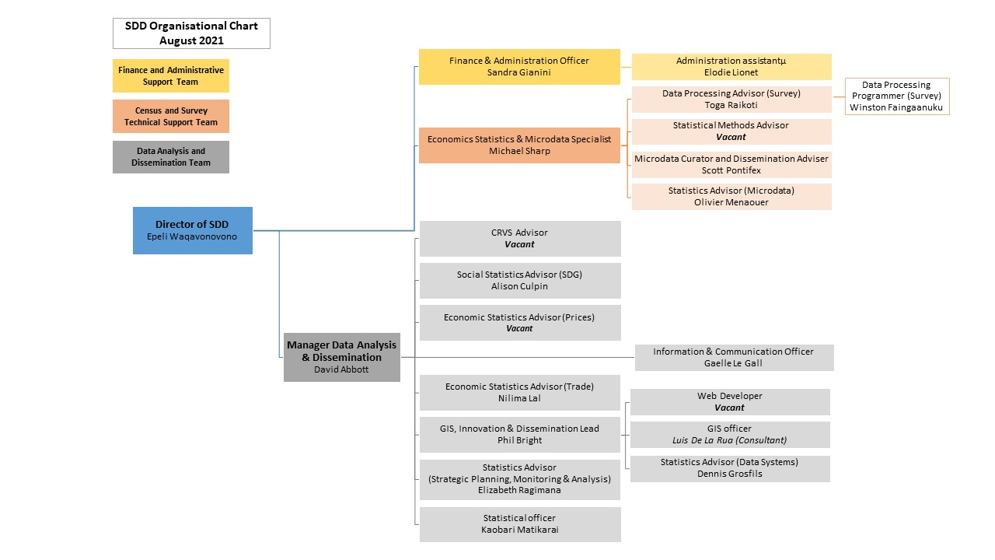

Key Result Areas (KRAs):

The Census and Survey Process and Method Advisor works under the general supervision of the Director for SDD and the Economic Statistics & Microdata Specialist and delivers on the following KRAs

- Playing a lead role in the development of statistical processes, procedures, methodologies and systems pertaining primarily to HIES and Population Census,
- Improve statistical practices within the region, with an emphasis on improved survey operations and associated capacity building to ensure that documentation on statistical processes, procedures, methodologies and systems, especially on HIES and Population Census, are kept up-to-date and key stakeholders are well informed,
- Ensure that quality HIES data are available and reported on in a timely manner for dissemination,
- Contributing to effective SDD team environment and SPC corporate activities,
- Contributing to SDD System Leader function/external stakeholder engagement, partnership and collaboration.

Jobholder is accountable for | Jobholder is successful when
KRA-1: Playing a lead role in the development of statistical processes, procedures, methodologies and systems pertaining primarily to HIES and Population Census (30 %) | - Current statistical processes, procedures, methodologies and system pertaining primarily to HIES and Population Census are fit for purpose in the context of providing a harmonised data collection platform in the Pacific.  - Harmonised statistical approaches and procedures, primarily on HIES and Population Census are endorsed by the Pacific Statistics Methods Board and adopted by most PICT member countries.  - Member countries are well informed on all revisions and/or new developments of statistical processes, procedures, methodologies and system pertaining primarily to HIES and Population Census.  - All significant feedback from member countries on statistical processes, procedures, methodologies and system pertaining primarily to HIES and Population Census are documented and shared with relevant SDD staff and Director with the objective of finding common solutions.  - Positive feedback continues to come from member countries on technical support given on HIES and Population Census.
KRA-2: Improve statistical practices within the region, with an emphasis on improved survey operations and associated capacity building to ensure that documentation on statistical processes, procedures, methodologies and systems, especially on HIES and Population Census, are kept up-to-date and key stakeholders are well informed (25%) | - Strengthen capacity of NSO staff in conduct surveys, especially HIES and Population Census, through technical assistance and training in survey design, operations and analysis.  - All submissions to the Pacific Statistics Methods Board on statistical processes, procedures, methodologies and system used in HIES and Population Census are coordinated and supported to ensure these are in line with international best practices.  - Strategies on ways of improving survey operations in the region, such as the RMI HIES Test Project, are well documented and Pacific Statistics Methods Board and member countries are informed.  - Documentation for surveys involved in, including extensive metadata input into the Pacific Data Hub – Microdata Library.  - The storage of survey metadata is actively supported.  - Produce a manual on HIES methods, system and procedure.  - A manual on HIES methods, systems and procedures is produced and kept up-to-date with revisions.  - Evaluation of training, course content and outputs by training participants  - Positive feedback on technical work is received from national and regional/international stakeholders.
KRA-3: Ensure that quality HIES data are available and reported on in a timely manner for dissemination (30%) | - All HIES final datasets are acquired from member countries; properly documented with metadata in place; and archived within SDD Pacific Data Hub – Microdata Library, and disseminated guided by Data License Agreements in place with member countries.  - Data analysis team receive final datasets with proper documentation for further analysis as inputs for compilation of National Accounts, Poverty Analysis, and CPI and with results disseminated in a timely fashion.  - Data Analysis and Dissemination Team are supported in the production of fact sheets; pocket statistical summary booklet; and all other divisional publications and dissemination activities.  - SDD data dissemination program is supported, including web-based regional statistical tables; and enquiries on HIES datasets are responded to on a timely manner.  - HIES and Population Census data are kept up-to-date and properly disseminated; SDD pocket summary and other divisional publications; and CPI reviews and re-base work enhance the quality of outputs to a suitable level.  - HIES reports are published within 12-months of completion of field work.
KRA-4: Contributing to effective SDD team environment and SPC corporate activities (5%) | - A multi-year work programme is developed and implemented in collaboration with SDD team members, in line with TYPSS Pacific Statistics Action Plan Phase 3 priorities, and SDD multi-year and multi-country data collection programme and to the satisfaction of NSS clients, SDD Director, and SDD Statistics Subject-Matter Specialists.  - Effective cross-programme collaboration and willingness to work with other SDD program colleagues (e.g. Health, Agriculture, LRD, GEM and FAME), notably on surveys, censuses, and other economic and related statistics, through in-country missions or through joint workshops is maintained and demonstrated.  - Recognised contributions are made to other SDD staff in the delivery of their KRA outputs as necessary.  - Active and positive participation is made in SDD meetings, reflections and workshops etc. including Pacific Statistics Methods Board, HOPS and PSSC.  - Timely and effective responses provided to SPC corporate activities, including Annual Performance Development System (PDS) reporting, Donor Reporting Requirements, CRGA, and other requests from SLT as required from time to time.  - Close technical collaboration is maintained with other SDD programme colleagues in both the collections team and the data analysis and dissemination team, and with other partners/stakeholders and SPC divisions as necessary.  - Technical support is provided to design/analysis of data collections, and to SDD’s dissemination activities as necessary.
KRA-5: Contributing to SDD System Leader function/external stakeholder engagement, partnership and collaboration (10%) | - Closely work with technical partners on all aspect of HIES and Population Census method, system and procedure  - Continued contributions are made to the United Nations Statistics Division, World Bank and other stakeholders/partners in support of census and survey activities as part of the regional collections programme.  - SDD and the region are professionally represented as necessary in international meetings, workshops and technical working groups relevant to the KRAs.  - Regular liaison and technical collaboration is fostered and maintained with key technical partners (e.g. PFTAC, ABS, ADB, UNESCAP, UN Stats, Stats NZ, PIFS, MSG, SIAP, USP)  - Work plans are shared/co-developed with technical partners to ensure effective coordination of technical assistance, and duplication is avoided.  - SDD is recognised as the focal point for all technical support on PHC and HIES methods, system and procedure under the partnership program.

Note: these performance standards are provided as a guide only. The precise performance measures for this position will require regular discussion between the jobholder and supervisor as part of the annual performance review process.

Work Complexity:

Most challenging duties typically undertaken:
- Co-ordination of complex programme activities across divisions, with most professional staff usually involved in more than one major substantive task.
- Conduct of training both nationally and sub-regionally across a wide range of complex topics, including sampling and survey design, survey implementation/management, data analysis and report writing, and CPI rebasing, and with counterparts of widely differing knowledge and skill levels.
- Provide extensive levels of technical assistance in most aspects of survey work, including project planning and budgeting; sampling; questionnaire design; training of national field staff and supervisors; data edits; data analysis and report writing.
- Working in countries and with technical partners where support and collaboration is not always reciprocal, or of a two-way nature.

Functional Relationships & Relationship Skills:

Key internal and/or external contacts | Nature of the contact most typical
External  - Government Statisticians across the Pacific  - NSO staff involved in census and household surveys  - Technical staff/specialists from other regional and international organisations, such as World Bank, ADB, PFTAC and ABS | - Co-ordinating support from SDD for technical assistance and training  - Training of staff and undertaking, technical assistance discussions  - Co-ordinating program collaboration, discussing technical matters and discussing budget issues
Internal  - SDD Director  - SPC Programme support services, such as Publications  - Other SPC technical divisions and staff as required | - Coordinate programme activities  - Assist with their work of colleagues in other divisions related to survey statistics

Level of Delegation:

Routine Expenditure Budget: 0

Budget Sign off Authority without requiring approval from direct supervisor: 50 Euros

Person Specification:

Qualifications
Essential: | Desirable:
- Master degree in statistics OR a similar relevant discipline e.g. mathematics or econometrics | - Training or attachment opportunities to more advanced NSOs on new methods, systems and procedures especially in population and household census and household income and expenditure survey (HIES).

Knowledge / Experience
Essential: | Desirable:
- Minimum of 10 years of demonstrated experience in population census and household survey methodology, systems and procedure;  - Broad statistical experience, particularly in the design and conduct of sample surveys and related areas of official statistics;  - Proven ability and experience in delivering statistical training, through both one-on-one technical collaboration and in formal workshop settings programmes;  - Strong communication skills, with the related ability to recognise and allow for cultural sensitivities;  - Highly developed organisational skills;  - Commitment to a teamwork-based approach to achieving programme and organisational goals;  - Computer Literacy, in particular as it relates to data processing (Stata, CSPro) and statistical analysis (R};  - Fluency in English, and working knowledge of French, in order to be able to deliver assistance to French speaking territories. | - Experience in developing countries, particularly in the Pacific region.

Key Skills /Attributes / Job Specific Competencies

The following levels would typically be expected for the 100% fully effective level:

Expert level | - Survey statistics methods, systems and procedures  - Statistical training ability
Advanced level | - All aspects of the survey cycle process, especially with regards to HIES and Population Census  - Communication and organisational skills  - Demonstrated knowledge and experience with Stata, R, CSPro and other relevant statistical packages
Working Knowledge | - Good working knowledge of survey-relevant IT software programs  - In English and French  - Good relationship management skills
Awareness | - Economic Statistics  - Advanced IT software used in statistics/surveys  - SPC Rules, Policies and Procedures

Key Behaviours

All employees are measured against the following Key Behaviours as part of their Performance Development:

- Change and Innovation
- Interpersonal Skills
- Teamwork
- Promotion of Equity and Equality
- Judgement
- Building Individual Capacity

Personal Attributes

- Patience when undertaking skill transfer
- Thoroughness and attention to detail
- Sound work ethic
- Good decision making ability
- Ability to handle pressure
- Ability to deal appropriately with a wide range of people at all levels
- Ability to plan ahead (allowing for mishaps)

Change to Job Description:

From time to time it may be necessary to consider changes in the job description in response to the changing nature of our work environment – including technological requirements or statutory changes. Such change may be initiated as necessary by SPC. This Job Description may be reviewed as part of the preparation for performance planning for the annual performance cycle.

