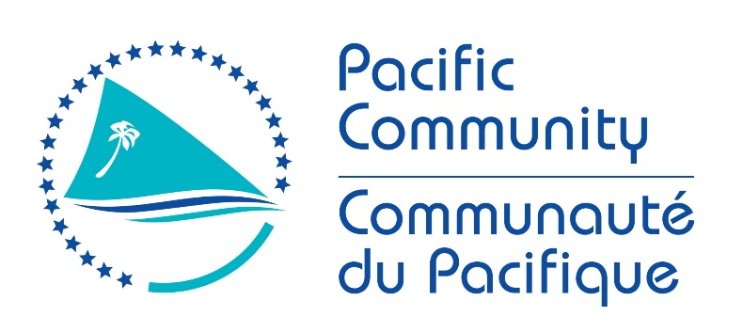

JOB DESCRIPTION
Job Title: | Project Technical Officer
Work Unit: | GEM
Location | Suva, Fiji
Responsible To: | GCCA+ SUPA Project Manager
Direct report: | None
Job Purpose: | Assist with the technical delivery of Output 3 of the GCCA+ SUPA Project, to scale-up resilient climate change adaptation development measures in specific sectors in ten countries. The Project Technical Officer will work across sectors and countries to (i) standardise adaption measures, prepare checklists and guidelines, and verify the scaling up methodology; (ii) prepare technical and supporting documents for service contracts and grant agreements and help coordinate their delivery; and (iii) contribute to the overall delivery of the project.
Date: | April 2022

Organisation Context:

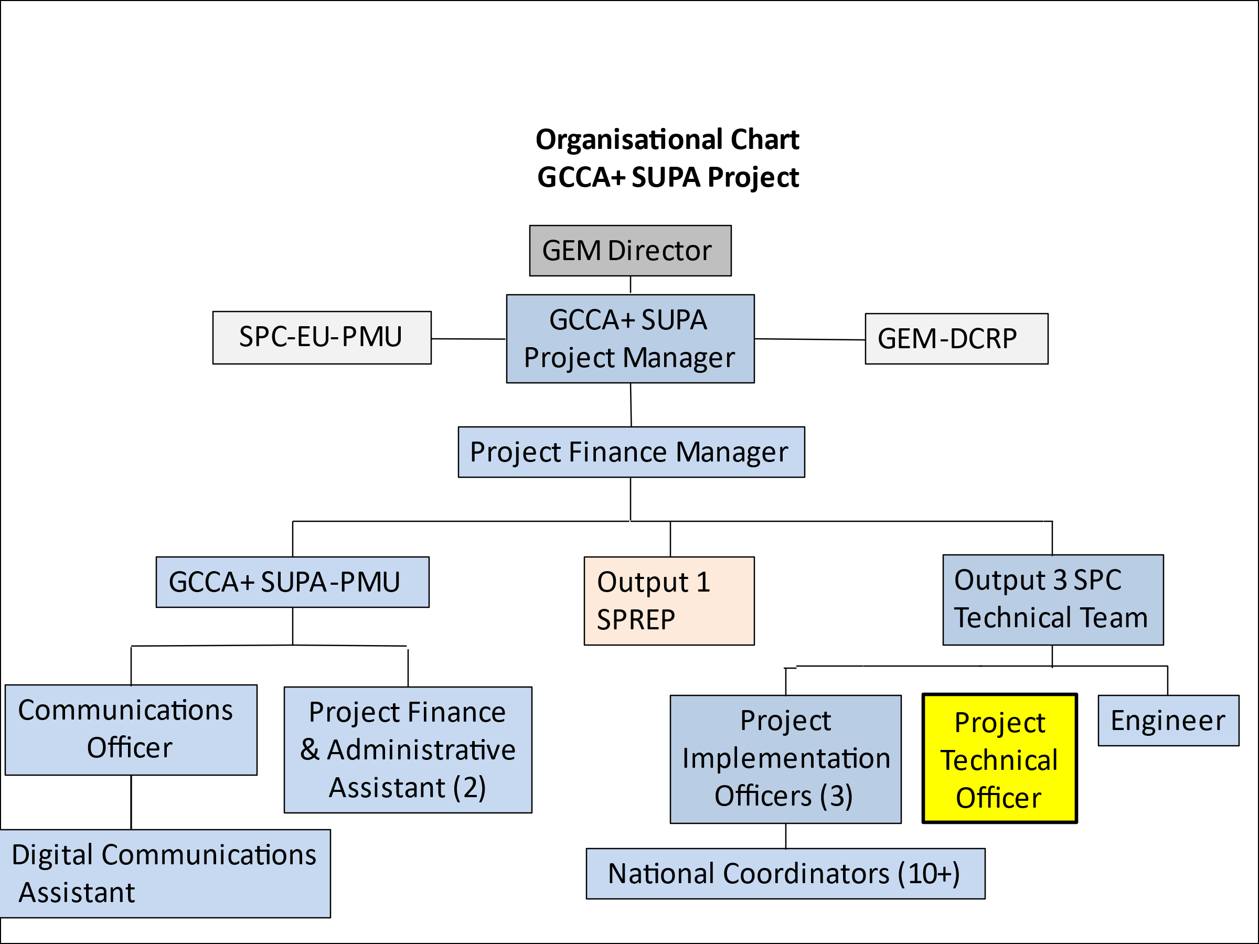

(Key: GEM = Geosciences, Energy & Maritime Division; GEP = Georesources and Energy Programme; PMU = Project Management Unit; CC = Climate Change)

The Pacific Community (SPC) is a regional organization assisting Pacific Island Countries and Territories to achieve their development goals by delivering technical, scientific, research, policy and training services. The SPC works across the region to assist member countries to better manage vulnerability and risks such as those associated with climate change, natural disasters and water security, including through the implementation of national and regional donor-funded projects.

One such project is the EU-funded Global Climate Change Alliance Plus Scaling up Pacific Adaptation (GCCA+ SUPA) project. The overall objective of the GCCA+ SUPA project is to enhance climate change adaptation and resilience within ten Pacific Island countries (Cook Islands, Federated States of Micronesia (FSM), Fiji, Kiribati, Marshall Islands, Nauru, Niue, Palau, Tonga and Tuvalu). The specific objective is to strengthen the implementation of sector-based, but integrated, climate change and disaster risk management strategies and plans.

The three outputs of the GCCA+ SUPA project are:
Output 1: Climate and disaster risk information, knowledge management, monitoring and strategic planning capacities strengthened at national and regional levels. (Delivery led by the Secretariat of the Pacific Regional Environment Programme (SPREP)).
Output 2: Planning and decision-making capacities to address climate change and disaster risks at sub-national and community level strengthened, applying participatory, gender-sensitive and rights-based approaches. (Delivery led by the University of the South Pacific (USP)).
Output 3: Strategic and local interventions for climate change adaptation and mainstreaming scaled up in up to five sectors. (Delivery led by SPC).

GCCA+ SUPA is implemented by SPC and SPREP, who have entered into a Co-Delegation Agreement with the European Union (EU) and with SPC as the Lead Organisation. The Co-Delegation Agreement covers the Project Management Unit (PMU) and the delivery of outputs 1 and 3. Delivery of Output 2 will be through a separate Grant Agreement between the EU and USP. The overall GCCA+ SUPA, while implemented through the two separate agreements, will adopt a framework of close collaboration and integration.

Key Result Areas:

The position of Project Technical Officer encompasses the following major functions or Key Result Areas:

- Conduct a compilation and analysis of the technical and socio-economic data from all the project’s climate change adaptation measures such that the methodology for scaling up climate change adaptation is verifiable and the results suitable for publication.
- Prepare the technical terms of reference and supporting documents for service contracts and grant agreements covering the climate change adaptation activities in each of the ten countries. Assist the project team with the coordination of the technical delivery of the service contracts and grant agreements.
- Undertake research and analysis of synergies within sector measures (water security, health and nutrition, coastal protection and marine resources) and the preparation of guidelines/checklists for standardization of measures in the ten countries included in the GCCA+ SUPA project.
- Contribute to national and regional training, technical exchange, capacity building and communication activities, and coordinate closely with CROP agencies delivering Outputs 1 and 2 of the project.

The requirements in the above Key Result Areas are broadly identified below.
Jobholder is accountable for | Jobholder is successful when
KRA 1: Conduct a compilation and analysis of the technical and socio-economic data from all the project’s climate change adaptation measures such that the methodology for scaling up climate change adaptation is verifiable and the results suitable for publication.
- Compile and summarise all the climate change adaptation measures under implementation through the GCCA+ SUPA project.  - Assess the scientific and socio-economic activities against the scaling up criteria designed in 2019.  - Analyse the extent to which the project’s activities comply with the criteria.  - Review the methodology for scaling up against the project evidence and verify.  - Assist with a publication if deemed appropriate by the project team. | - All climate change adaptation measures implemented through SUPA compiled and assessed against the 2019 scaling-up criteria.  - Climate change adaptation activities analysed to verify the methodology for scaling-up based on an evidence approach.  - Draft publication on scaling up prepared.
KRA 2: Prepare the technical terms of reference and supporting documents for service contracts and grant agreements covering the climate change adaptation activities in each of the ten countries. Assist the project team with the coordination of the technical delivery of the service contracts and grant agreements.

- Prepare the technical terms of reference for service contract and grant agreements required for on-the-ground scaling up measures and compile all the supporting documents.  - Design and regularly update matrices to guide the technical delivery of all service contracts and grant agreements in the ten countries.  - Design and track linkages between the technical delivery of the activities and the payment system being managed by the project’s finance team.  - Provide any assistance as may be required to the project team with the quality review of the technical deliverables (policies, plans, engineering structures, communication measures). | - Service contracts and grant agreements across sectors with all supporting documents, accurately prepared.  - Technical delivery of all service contracts and grant agreements regularly monitored such that all activities are fully delivered in the project time frame.  - System effectively functioning to link the technical delivery of climate change adaptation measures and the payment schedule  - Technical deliverables fully quality controlled.
KRA 3: Undertake research and analysis of synergies within climate change adaptation sector measures (water security, health and nutrition, coastal protection) undertaken by the project and the preparation of guidelines/checklists for standardization of measures in the ten countries included in the GCCA+ SUPA project.
- Review the checklists and guidelines already prepared for the implementation of climate change adaptation measures in the water security, health, coastal protection and marine resources sectors in the project countries and revise and update. | - Guidelines and checklists reviewed and updated for implementation of climate change adaptation measures in the following sectors: water security, health, coastal protection and marine resources.
KRA 4: Contribute to national and regional training, technical exchange, capacity building and communication activities, and coordinate closely with CROP agencies delivering Outputs 1 and 2 of the projects.
- Contribute to and assist with project plans for gender-sensitive/rights-based approaches, communications, risk management, exit and closure strategies.  - Assist with national and/or regional technical training.  - Assist with technical exchanges and peer-to-peer exchanges.  - Provide information and materials to the Communications Officer so that the project visibility in maximised in real time and the website is up-to-date.  - Assist with the planning, design, delivery and reporting of regional steering committee meetings and lessons learnt meetings and activities.  - Collaborate closely, provide input and share information with SPREP team partners charged with the delivery of Output 1.  - Collaborate, provide input and share information with USP partners charged with the delivery of Output 2.  - Reference the overall framework of GCCA+ SUPA with delivery by different partners in all communications with country partners. | - Project plans for gender-sensitive/rights-based approaches, communications, risk and exit are updated annually.  - Technical training for country partners is delivered in an efficient and timely manner.  - Opportunities for exchanges are identified and implemented.  - Communications Officer is kept up-to-date with national activities and documentation provided to up-date the website.  - Regional steering committee meetings, which include opportunities for training and lessons learnt, are held and effective in achieving their goals. Lessons learnt compiled.  - Close interaction between the SPREP team delivery output 1 and the output 3 activities.  - Close interaction between the USP team delivering output 2 and the output 3 activities.

Note

The above performance standards are provided as a guide only. The precise performance measures for this position will need further discussion between the jobholder and supervisor as part of the performance development process.

Work Complexity:

Most challenging duties typically undertaken:

- Analysis of semi-quantitative data from several different disciplines from physical sciences and social science and including water security, food security, human health, coastal and marine resources.
- Understanding and communicating the principles of scaling-up in Pacific climate change adaptation work.
- Bridging the divide between substantive and technical deliverables and financial schedules
- Cost benefit analysis in a “data sparse” environment
- Accessing information and data.
- Working across multiple agencies and multiple sectors in ensuring delivery of Output 3.
- Coordinating and facilitating information exchange, networking and partnership building with other donor funded projects.

K

Functional Relationships & Relationship Skills:

Key internal and/or external contacts | Nature of the contact most typical
External  - Regional organisations, especially SPREP and USP, and others e.g. CROP, IOM, UN agencies  - Donor – EU and other development partners  - National and sector government agencies  - National NGOs, civil society, private sector, women’s and youth groups  - Recipient communities in the countries  - Media (national and regional)  - Consultants and firms  - Climate change and disaster risk management networks  Internal  - GEM Director  - SPC’s PMU for EU projects  - SPC Operations and Management teams  - SPC’s GCCA+ SUPA PMU and Output 3 team  - Professional staff in GEM, LRD, SSD, SPL, PHD, CCES, RRRT  - RENI team | Consultation, reporting and negotiation  Consultation  Direct national liaison  Service provision and support  Public relations  Strategic collaboration (research and extension activities)  Data sharing, reporting, liaising, facilitating, and coordination of project support and activities

Level of Delegation:

The position holder does not have budgetary sign-off.

Person Specification:

Qualifications
Essential: | Desirable:
- Post graduate degree in natural resources management, environment management, climate change or a related field.

Knowledge / Experience
Essential: | Desirable:
- At least 6 years professional experience working with Pacific Island countries in areas relating to climate change, disaster risk management and capacity building.  - At least 4 years’ experience working in regional/international organisations to design and deliver donor-funded, climate change projects in the Pacific islands.  - Demonstrated experience with the implementation of multi-sector projects in a cross-cutting field such as climate change.  - Proven track record in the monitoring and evaluation of project outputs.  - Experience with multi-stakeholder participatory and consultative approaches including gender sensitive and rights-based approaches.  - Excellent interpersonal skills in the multicultural environment of the Pacific Islands.  - Excellent English communication skills (oral and written).  - Excellent computer skills across necessary applications. | - Experience of working with small communities in Pacific islands.  - Experience with projects funded by the EU.

Key Skills /Attributes / Job Specific Competencies

The following levels would typically be expected for the 100% fully effective level:

Expert level | - Competency in the analysis of semi-quantitative data from different disciplines.  - Competency in participatory and consultative approaches, and the assessment of technical and socio-economic data  - Preparing cost estimates for the implementation of climate change adaptation measures (policies/plans, engineering works, training & capacity building)  - Experience with implementation of projects that also address climate change, disaster risk and environmental management in remote locations.  - Experience with monitoring and evaluation.
Competency Advanced level | - Capacity building and mentoring skills.  - Efficient delivery of outputs and writing skills.  - Ability to work under pressure.  - Effective communicator and a good listener.  - Excellent written and spoken English.  - Attention to detail.  - Coordination and liaison.  - Principles of procurement and financial management.  - Computer literacy, particularly with Microsoft Office and related project management software.  - Ability to deal with confidential information in a professional manner.
Working Knowledge | - Behavioural change methods.  - Gender-sensitive and rights-based tools.
Awareness | - EU and SPC policies and procedures.

Key Behaviours

All employees are measured against the following Key Behaviours as part of Performance Development:

- Change and Innovation
- Interpersonal Skills
- Teamwork
- Promotion of Equity and Equality
- Judgement
- Building Individual Capacity

Personal Attributes

- Self-motivated
- Demonstrates cultural and gender sensitivity
- Ability to think and act on initiative
- Strong client orientation and continuous improvement mindset
- Highly motivated and strong affinity to teamwork
- Analytical and smart thinking – solutions oriented
- High work standards, good work ethic and positive attitude to work
- Proactive with creative ability to meet deadlines, achieve objectives and master new material quickly
- Performs well under pressure and strongly committed to work
- Positive attitude, excellent interpersonal skills, well organized, dependable and honest

Change to Job Description:

From time to time, it may be necessary to consider changes in the job description in response to the changing nature of our work environment – including technological requirements or statutory changes. Such change may be initiated as necessary by SPC. This Job Description may be reviewed as part of the preparation for performance planning for the annual performance cycle.

