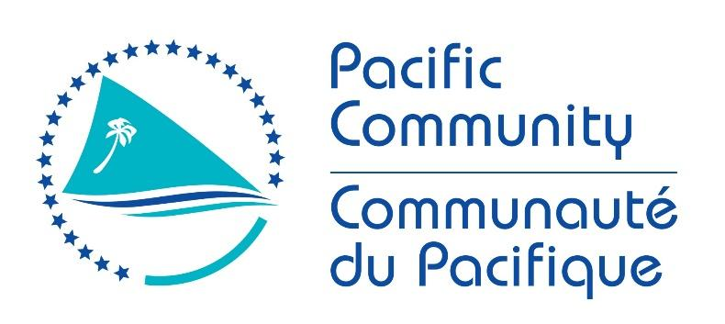

JOB DESCRIPTION
Job Title: Project Manager - Organic Learning Farms Network
Department and Project: Pacific Organic and Ethical Trade Community, Land Resources Division
Location: Suva, Fiji
Reporting to: Reporting to: POETCom Coordinator, Land Resources Division (LRD)
Direct Reports: 5 (4 Country Coordinators; Fiji, Nauru, Tonga and Solomon Islands and 1 Project Assistant)

Purpose of Role: The Project Manager will provide strategic vision, management, and direction for the Pacific Organic Learning Farm Network – Agro ecology and agro forestry for climate resilience project. The Project Manager will oversee implementation of all aspects of the project including coordination of the staff and partners involved at national (producers, government institutions) and regional levels, and internally within SPC. The position is responsible for in-country activity implementation in Fiji, Nauru, Tonga and Solomon Islands, financial management, reporting and operations.

Date: March 2021

Organizational Context

Pacific Organic and Ethical Trade Community- POETCom is the peak body of the organics movement in the Pacific, housed within the Pacific Community (SPC). The membership of POETCom is broad based and multisectoral with representation from organic farmers, farmer organizations, traders, Governments, academic and research institutions, NGOs, private sector businesses and regional technical support agencies such as FAO and SPC. The Role of the POETCom is to serve as the regional peak body for the organics industry and to advocate at the international level on issues that impact on the development of organics in the Pacific and at regional and national levels for the promotion and development of organics to reach the vision. POETCom developed and manages the Pacific Organic Standard [POS] and the Pacific Organic Guarantee Scheme [POGS].

The position is supported through the KIWA Initiative: Nature-based solutions for climate resilience since the Organic Learning Farms Network project is a regional project funded in the framework of this Initiative (www.kiwainitiative.org).
The KIWA Initiative aims at strengthening the climate change resilience of Pacific Island ecosystems, communities and economies through Nature-based Solutions (NbS), that is to say by protecting, sustainably managing, and restoring biodiversity. It is based on easier access to funding for climate change adaptation and NbS for local, national authorities, civil society and regional organisations of Pacific Island countries and Territories including the three French overseas territories. The Initiative, managed by the Agence Française de Développement (AFD), is funded by the European Union, AFD, Global Affairs Canada, Australian Government Department of Foreign Affairs and Trade (DFAT) and New Zealand Ministry of Foreign Affairs and Trade (MFAT).

The Pacific Organic Learning Farm Network – Agro ecology and agro forestry for climate resilience project is a four-year project that will be operational in Fiji, Nauru, Tonga and Solomon Islands, with exchange and learning components with Wallis and Futuna, New Caledonia and French Polynesia in collaboration with the European Development Fund 11 PROTEGE project implemented by the Pacific Community.

The overall objective of the project is the development of organic farming systems for food security, climate change adaptation, and biodiversity conservation in order to strengthen resilience of smallholder producers through the establishment of a network of Organic Learning Farms (OLFs). These organic farms will demonstrate the best organic and agroecological production methods, with a focus on enhanced biodiversity, that can be adopted by smallholder producers. These farms will demonstrate the benefits of biodiversity, agro ecology, agro forestry and organic production methods and technologies for climate resilience.

The program’s specific Components are:
Component 1: Establishment of Organic Learning Farm network
Component 2: First circle farmers trained and supported in converting their farms to organic and agroecological practices
Component 3: Ensuring sustainability through market incentives
Component 4: Monitoring, knowledge management learning and visibility

Organisation Chart

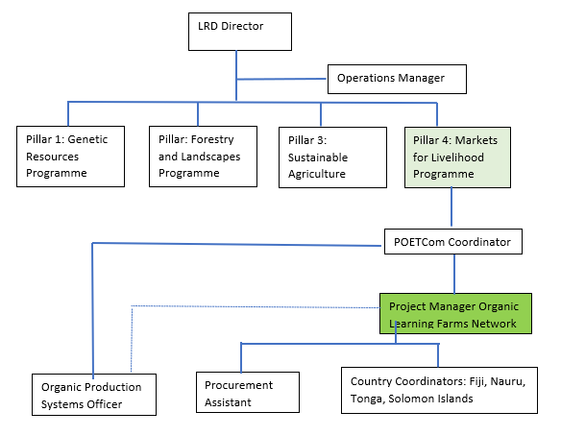

Key Result Areas (KRAs):

The position of Project Manager encompasses the following major functions or Key Result Areas for the Pacific Organic Learning Farm Network project within the Land Resources Division:

Key Result Area 1: Project Management
Key Result Area 2: Supervision, mentoring and supporting staff & consultants
Key Result Area 3: Facilitation of effective communication among and between national partners and regional development partners.

The performance requirements of the Key Result Areas are broadly described below

Jobholder is accountable for | Jobholder is successful when
Key Result Area 1: Project Management  (45%)  • Oversee the development of project management systems and processes including risk management and monitoring and evaluation.  • Ensure the effective implementation of the Organic Learning Farms Network project, including implementation planning and monitoring, problem solving, managing budget execution.  • Coordinate and communicate across project partners to ensure effective  communication and management of any project-related issues that may arise.  • Ensures donor contract compliance and that narrative and financial reports are of high quality and completed in a timely manner. | i) Organic Learning Farms Network project is executed on time, delivers results, and complies with donor financing agreement and reporting obligations.  ii) Organic Learning Farms Network project is effectively and efficiently managed, including coordination and communication across project partners following the KIWA Initiative communication guidelines, and the timely development and execution of annual work plans.  iii) Organic Learning Farms Network project financial and narrative reports completed to a high standard and completed in a timely manner.  iv) Strong linkages are established with other POETCom activities and programs in the Division, with other relevant divisions and key projects in the Pacific for a robust impact pathway established with stakeholders.
Key Result Area 2: Supervision, mentoring and supporting staff & consultants (35%)  • Supervises overall performance of project staff and consultants.  • Provides advice, mentoring and support in design and delivery of national activities and other activities in relation to the project.  • Develops TORs for project consultants and manages consultant contracts.  • Ensures that 6-monthly plans and budgets of staff are accurate, realistic and meet the project objectives and are regularly monitored and reviewed.  • Ensures staff performance appraisals are completed mid-year and annually. | i) Appropriate consultants are recruited to meet project objectives.  ii) Staff and consultants are effectively managed and deliver results on time and within budget.  iii) Staff performance appraisals are completed.
Key Result Area 3: Facilitation of effective communication among and between national partners and regional development partners. (20%)  - Oversee the development and monitoring of an effective communications plan with project counterparts concerning the implementation of project activities including (i) high-level liaison with permanent secretaries and other senior government staff where required and (ii) consultation with NGOs, civil society groups, women’s groups, and others.  - Oversee implementation of the communications and visibility strategy, including the development of communications materials, for the Organic Learning Farms Network project following the KIWA Initiative communication guidelines.  - Support to project country beneficiaries on communication needs in relation to the project delivery.  - Leadership of the effective liaison and promotion of networking between key stakeholders and other individuals involved in project implementation, between projects where relevant, and with the beneficiaries of the EU funded PROTEGE project implemented by SPC. | i) Effective communications are established and maintained with appropriate contact points, including permanent secretaries, senior government staff, focal points, stakeholder representatives, NGOs, civil society, and women’s groups.  ii) A project communications plan is effectively designed, implemented, and monitored following the KIWA Initiative communication guidelines.  iii) Project activities and delivery are promoted in a variety of media and websites (including SPC and the KIWA Initiative websites).  iv) Open and effective communications are actively promoted between and within project beneficiaries and SPC programmes and project teams.  v) Lessons learned are shared throughout the Pacific region through POETCom and other mechanisms, especially with the beneficiaries of the EU funded PROTEGE project implemented by SPC.
The above performance requirements are provided as a guide only. The precise performance measures for this job will need further discussion between the jobholder and supervisor as part of the performance development process.

Most Challenging Duties Typically Undertaken (Complexity):

- Ensuring operational activities of the Organic Learning Farms Network project are effective, efficient, relevant, and sustainable given its nature and the complexity environments in which the project will be implemented, and that budget is efficiently and effectively managed.
- Ensuring comprehensive and accurate reporting of activities and financials of the project to SPC and the KIWA Initiative.
- Coordinating the various stakeholders and activities within the project.
- Assuring the balance of commercial viability, sustainability, and educational quality of the Organic Learning Farms.
- Work cooperatively with diverse stakeholders of different cultures and viewpoints, to develop and manage a high-quality project while maintaining high integrity and trust.

Functional Relationships & Relationship Skills:

Key internal and/or external contacts | Nature of the contact most typical
External –  - PICT Governments and other national stakeholders.  - Private companies, research institutes, training institutes.  - POETCom Affiliates.  - Donors and development partners.  - CROP agencies and other regional bodies and associations.  - NGOs.  - Government Agencies (Regionally).  - Agence Française de Développement.  - The KIWA Initiative Secretariat. | - Project implementation.  - Partnerships/collaborations on identification and implementation of best practices.  - Collaboration and joint approaches for complementary project activities and on-going /planned activities with those of other stakeholders.  - Representation of POETCom members interests and priorities.  - Collaboration, partnerships, and the promotion of joint events.  - Strategic collaboration (capacity building).  - Strategy development/implementation.  - Service provision and support.  - Information dissemination.
Internal  Key internal contacts are:  - POETCom Coordinator  - POETCom Staff  - SPC Executive  - Director LRD  - Other LRD Program Leaders and Technical Advisers  - LRD and SPC staff  - POETCom Board that includes representative members from each participating country, as well as from the PROTEGE project and AFD for this specific project. | - Liaising on the future direction of the project and links to other POETCom and LRD activities  - Advice on direction and implementation of Organic Learning Farms Network project in line with LRD strategic direction.  - Integrated approach to implementation of LRD business plan requiring closer working relationship with the other LRD programs.  - Contribute to the delivery of the Division’s business plan.

Level of Delegation:

Routine Expenditure Budget: 1,200,000 EUR annually

Budget Sign off Authority without requiring approval from direct supervisor: 50 EUR per commitment

Personal Specification:

This section is designed to capture the expertise required for the role at the 100% fully effective level. (This
does not necessarily reflect what the current position holder has.) This may be a combination of knowledge /
experience, qualifications, or equivalent level of learning through experience or key skills, attributes, or job
specific competencies.

Qualifications

Essential: | Desirable:
- Bachelor’s degree in governance, agricultural economics, international development, management, or a related field required. | - Demonstrated experience in multi-country project management role within a public service, NGO, or regional/international organisation.  - Advanced degree in governance, management, development studies, agriculture, forestry, social science, or related field.

Knowledge/Experience

Essential: | Desirable:
- Minimum 5 years of project management and staff supervision experience. Experience working on a donor-funded project is highly desirable.  - Minimum 10 years of work experience on agricultural, sustainable development, environmental or economic growth programs or activities in the Pacific.  - Good knowledge of climate change and biodiversity issues in the Pacific.  - Good knowledge of climate adaptation issues in the agriculture sector.  - Understanding of the role of biodiversity for climate adaptation.  - Fluency in English; excellent oral and written skills required.  - Excellent communicator, with strong verbal, writing and editing skills.  - Excellent computer skills across necessary applications including database management.  - Financial, human resource and administrative management skills in a challenging environment, with a particular focus on stakeholder management and monitoring programme/organizational performance.  - Representative experience through work at the national, regional and international levels with a particular focus on advocacy, with a view to developing and maintain key relationships.  - Interpersonal skills across a multicultural environment, able to deliver information within a cross-cultural context.  - Development and evaluation of learning/training materials and tool kits.  - Understanding of agricultural systems in the Pacific. | - Demonstrated experience in a project management role within a public service, NGO, or regional/international organisation.  - Demonstrated understanding of emerging issues relating to organic and sustainable agriculture, climate change or inclusive value chain development.  - Experience in managing project(s) across multiple countries.  - Experience with a national, regional, or international organization dealing with issues of agriculture, environment and/or sustainable livelihoods development.  - Experience in supporting the development of policy and provision of technical advice and support through an NGO or association.  - Demonstrated understanding of key social, economic, and political challenges faced by the Pacific Islands region.  - Demonstrated understanding of key challenges and constraints impeding Pacific Islands access to organic and ethical markets.  - Extensive (> 5 years) relevant work experience in the Pacific Islands and/or tropical, developing countries.  - Medium knowledge of French
Key Skills/Attributes/Job Specific Competencies

The following levels would typically be expected for the 100% fully effective level:

Expert level | - Project management including financial management.  - Coordinating and Negotiations.  - Report and Proposal writing, planning, and organizing.  - An understanding of the culture and traditions and ways of working of the various Pacific Island Countries.
Advanced level | - Interpersonal skills.  - Attention to detail with high computer literacy.  - Communication and responsiveness to needs of stakeholders.  - Advocacy with demonstrated initiative and ability to think laterally to identify innovative solutions.
Working knowledge | - Using data and information management systems.  - POETCom Strategic plan, SPC SP, LRD Business Plan.  - Country agricultural policies and plans and national strategic action plans.  - Agriculture practices in the context of climate change and biodiversity conservation.
Awareness | - SPC policies and procedures.  - LRD Office Procedures.  - Organic certification and guarantee systems.  - Organic trade requirements.

Key Behaviours

All employees are measured against the following Key Behaviours as part of Performance Development:

- Commitment/ Accountability
- Professional/Technical Expertise
- Teamwork
- Customer Focus
- Effective Communications & Relationships
- Organization and attention to detail
- Negotiation/diplomacy
- Coaching and Development
- Strategic Perspective

Personal Attributes

- A good understanding of the cultures and the working environment in member countries and the ability to be proactive in developing new ideas to serve and to address the needs of member countries.
- High level of Professional Integrity and Ethics including confidentiality.
- Negotiation and diplomacy skills to reach consensus among stakeholders with different and passionately held views.
- Excellent communication skills with fluency in verbal and written English are essential to communicate with member country governments and other regional and international organisations. Knowledge of other languages spoken in the region is an asset.
- Strong computer literacy, preferably with Microsoft programs [Word, Excel, Access, Outlook, PowerPoint] and ability to use database, E-mail and the Internet. Knowledge of other programs such as Adobe and MapInfo and an understanding of spreadsheet and principles would be an advantage.
- Motivational skills with professional initiative and good work ethics with demonstrated ability to take initiative and draft succinct, simple, and understandable implementation plans.

Change to Job Description:

From time to time it may be necessary to consider changes in the job description in response to the changing nature of the work environment - including technological requirements or statutory changes. Such change may be initiated as necessary by SPC. This Job Description may also be reviewed as part of the preparation for performance planning for the annual performance cycle.

