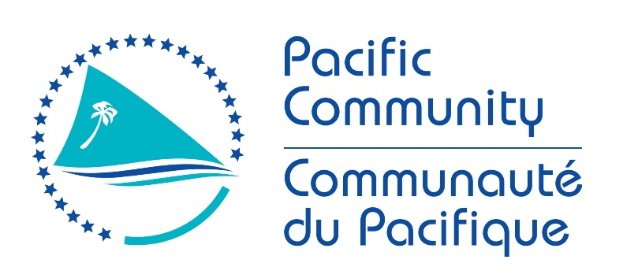

JOB DESCRIPTION

Job Title: | Senior Fisheries Adviser (E-Technologies)
Division/Programme  and Section/Project (if any): | Oceanic Fisheries Programme (OFP)
Location: | Noumea
Reporting to: | Principal Fisheries Scientist (FEMA)
Number of Direct Reports: | 1
Purpose of Role: | To ensure that national, sub-regional and regional oceanic fisheries management is enhanced through the establishment of E-technologies (E-Reporting and E-Monitoring) to support the highest quality and consistent fisheries monitoring across the region.
Date: | October 2021

Organizational Context and Organization Chart

The Fisheries, Aquaculture and Marine Ecosystems (FAME) Division has two core units, the Oceanic Fisheries Programme (OFP) and the Coastal Fisheries Programme (CFP). In line with the FAME Business Plan, the goal of the OFP is that fisheries exploiting the region’s resources of tuna, billfish and related species are managed for economic and ecological sustainability using the best available scientific information. In pursuing this goal, the OFP provides scientific support for the management of fisheries for tuna and associated species, with a strong focus on stock assessment and modelling, fisheries and ecosystem monitoring and analysis and data management. The OFP works closely with member countries and territories, the Western and Central Pacific Fisheries Commission, the Forum Fisheries Agency, the Parties to the Nauru Agreement and other regional and sub-regional entities.

The OFP is currently organized into three sections, the Stock Assessment & Modelling Section, the Data Management Section and the Fisheries & Ecosystem Monitoring & Analysis (FEMA) Section. The programme is supported by a Finance & Administration Unit. This position will provide advice and leadership to SPC membership and it regional and sub-regional partners on the application of E-technologies to enhance fisheries monitoring capabilities and performance. The position sits within the FEMA section’s ‘Fisheries Monitoring’ team. The OFP organizational chart is shown below:

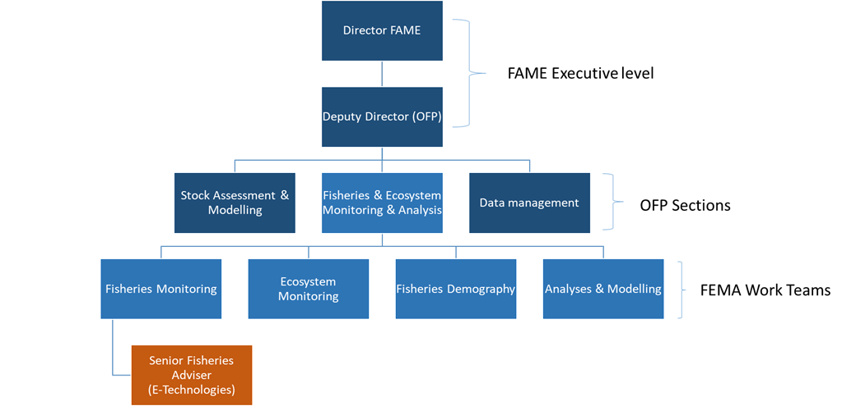

Key Result Areas (KRAs):

The position of Senior Fisheries Adviser (E-Technologies) encompasses the following major functions or Key Result Areas:
- Leadership, administration and communication.
- Develop and implement proposals and work plans that facilitate the integration of E-Technology into regional fisheries monitoring and research activities, primarily focusing on the acquisition of data for science from at-sea monitoring to augment the output of observers, but also potentially including port-sampling activities, Pacific Marine Specimen Bank and Catch documentation and traceability activities.
- Transition E-Technology solutions into standard practice within fisheries monitoring programmes in the western and central Pacific Ocean, with member countries, regional and subregional partners.
- Builds capacity of SPC members in the relevant E-Technologies adopted for fisheries monitoring.

The performance requirements of the Key Result Areas are broadly described below

Jobholder is accountable for | Jobholder is successful when
- Transitioning E-Technology solutions into standard practices (50%)  - Consult and participate in national and regional processes to develop E-reporting and E-monitoring operational and data standards  - Consults with members regarding their fisheries monitoring needs and designs digital solutions (where appropriate) that contribute to meeting those needs,  - Formulate advice on E-reporting and E-monitoring issues as they relate to scientific data collections for SPC members, CROP agency partners and WCPFC  - Investigates potential of E-Technology Systems to support to SPC initiatives for enhanced data collection and curation.  - Oversees and contributes to the delivery of other E-Reporting and E-Monitoring activities and projects | - Regional standards for E-Technology covering scientific data for fisheries monitoring are established through the work of the SPC/FFA/PNAO Data Collection Committee and other regional/subregional processes, based on clear requirements.  - Demonstrated uptake of regionally adopted E-Technology standards for fisheries monitoring.  - Members and CROP agency partners are aware of the potential of new E-Technologies for acquiring scientific data through special projects to improve fisheries monitoring, including  - SPC has investigated and described the potential of new E-Technologies for acquiring scientific data  - Regional E-Reporting and E-Monitoring projects are executed according to work plans and budgets
- Implements integrated E-Technology systems (20%)  - Develop E-Technology solutions for scientific data collection in consultation with SPC members and CROP agency partners based on the agreed standards and requirements.  - Ensures quality assurance processes for the scientific data acquired through E-Technologies are implemented | - Standardised and verifiable E-Reporting and E-Monitoring systems are increasingly used for fisheries monitoring in the region, including  - E-Reporting systems supported by SPC have been widely and actively promoted throughout the region through regional and national meeting presentations and other means;  - E-Reporting systems supported by SPC are implemented [through the SPC Regional ER Coordinator], where requested;  - Assistance has been provided to member countries to implement E-Monitoring systems [through the SPC Regional ER Coordinator], where requested;  - Relationships have been established with third party E-Technology providers including regular liaison to ensure, for example, their systems adhere to the regional E-Technology SSPs;  - Relevant advice provided, and collaboration with Data Management team in the ongoing development of E-Reporting tools for the collection of scientific data through fisheries monitoring;  - E-Technology systems used in SPC member countries have regular reviews/systematic audits of fisheries science data collection.
- Capacity building of SPC members in fisheries monitoring (15%)  - Delivers regional vocational training in E-Technologies  - Reviews existing E-Technology platforms and undertakes capacity needs analysis | - Capacity building programmes are implemented according to annual work plans and budgets  - SPC members demonstrate increased capacity in the use of digital technologies.
The above performance requirements are provided as a guide only. The precise performance measures for this job will need further discussion between the jobholder and supervisor as part of the performance development process.

Most Challenging Duties Typically Undertaken (Complexity):

  - Managing a diverse work programme including high demands for support from other OFP sections, SPC members and other clients in funding-limited situations.
  - Analysis of current regional E-Technology systems with view to enhancement through innovation.
  - Innovative but pragmatic approach to new solutions for E-Technology for Fisheries Monitoring
  - Negotiating options for E-Technology solutions in a diverse and complex socio-economic environment.
  - Developing and implementing QA processes to ensure that monitor standards in E-Technologies are implemented and maintained.
  - Implements scalable E-Technologies across the diverse work programme of FAME.
  - Provision of concise and authoritative on-the-spot advice to members are national, sub-regional and regional meetings.
  - Organising and conducting training courses in a dynamic environment with limited resources.

Functional Relationships & Relationship Skills:

Key internal and/or external contacts | Nature of the contact most typical
External:  - SPC member fishery departments and the additional WCPFC member countries fisheries agencies  - Secretariat of the Western and Central Pacific Fisheries Commission  - Secretariat of the Forum Fisheries Agency  - PNA Office  - The South Pacific Regional Environment Programme  - E-Technology service providers  - Donors, including government, civil society, NGOs and industry  - National Fisheries E-Technology Coordinators and Officers | - Requests for assistance in fisheries monitoring and capacity building  - Liaising with senior officers regarding their E-Technology requirements, trials and implementation.  - Liaising with regional/sub-regional agencies in respect to the development of new or enhancing existing E-Technology standards and systems through the SPC/FFA/PNAO Data Collection Committee (for example), and relevant WCPFC processes.  - Development of work plans and budgets  - Development of reports, papers and proposals  - Liaising with government officials and NGOs on funding bids and reporting on existing projects and programmes
Internal:  - OFP Manager / Deputy Director, FAME  - OFP Oceanic Data Management, Ecosystem Monitoring and Analysis, and Stock Assessment and Modelling Sections  - Coastal Fisheries Programme  - Other SPC technical Divisions – PHD, GEM and SSD  - PCCOS  - OMD and SPL | - Collaboration with groups, new knowledge generation and provision of data & data products for incorporation into work undertaken across the Programme  - Management, direction and advice to team members  - Provision of advice on sources, content and quality of data  - Assistance in analyses to scientific staff  - Contribution to project management  - Leadership liaison with the Fisheries Monitoring team leader

Level of Delegation:

The position holder has no delegated responsibility as per SPC’s Instrument of Delegation.

Personal Specification:

This section is designed to capture the expertise required for the role at the 100% fully effective level. (This does not necessarily reflect what the current position holder has.) This may be a combination of knowledge / experience, qualifications or equivalent level of learning through experience or key skills, attributes or job specific competencies.

Qualifications

Essential: | Desirable:
- Master degree in fisheries science, fisheries management or related discipline | - A PhD degree in fisheries science or related discipline

Knowledge/Experience

Essential: | Desirable:
- A minimum of 10 years of demonstrated expertise in developing and progressing the monitoring requirements for scientific work and/or the management of fisheries.  - Demonstrated competencies in the application of E- technologies and/or fisheries intelligence systems for fisheries monitoring and scientific data collection.  - Well-developed and demonstrated facilitation and negotiation skills.  - Demonstrated experience in writing reports, meeting papers and proposals  - An excellent knowledge of e-reporting and e-monitoring tools and policies as they apply to tuna fisheries in the western and central Pacific Ocean  - Communication and inter-personal skills of a high order required to interact with colleagues from member countries, CROP agencies and industry specialists | - Considerable experience in tuna fisheries in the Western and Central Pacific  - Experience as an analyst of data derived from E-technologies  - Experience in the application of fisheries monitoring in pelagic fisheries  - If anglophone, a working knowledge of French. If francophone, a working knowledge of English.

Key Skills/Attributes/Job Specific Competencies

The following levels would typically be expected for the 100% fully effective level:

Expert level | - Knowledge of tuna fishery monitoring and tuna data quality systems.  - Project development and management in an international context.  - Aptitude for the provision of high-quality service and advice
Advanced level | - Fisheries monitoring techniques (data collection systems) related to scientific data requirements  - WCPO Tuna Fisheries  - E-Technology approaches for monitoring fisheries  - Oral and written communication skills  - Staff supervisory skills (internal)  - Organizational skills  - Communication skills  - High-level interpersonal skills (internal and external)  - A flexible approach and a willingness to assist with a variety of tasks, as required.
Working knowledge | - Tuna fishing operations  - WCPFC key documents and purpose  - Technical report writing  - Auditing concepts  - Ability to design and conduct training courses  - Ability to deal with confidential information in a professional manner.  - English and French language
Awareness | - Fisheries stock assessment methods  - Tuna biology  - Fisheries management principles  - Tuna Fisheries in other oceans  - SPC policies relating to recruitment, gender, harassment, and others

Key Behaviours

All employees are measured against the following Key Behaviours as part of Performance Development:

  - Change and Innovation
  - Interpersonal Skills
  - Teamwork
  - Promotion of Equity and Equality
  - Judgement
  - Building Individual Capacity

Personal Attributes

  - High level of professional integrity and ethics
  - Friendly demeanor
  - Demonstrated high level commitment to customer service

Change to Job Description:

From time to time it may be necessary to consider changes in the job description in response to the changing nature of the work environment - including technological requirements or statutory changes. Such change may be initiated as necessary by SPC. This Job Description may also be reviewed as part of the preparation for performance planning for the annual performance cycle.

JOB DESCRIPTION

Job Title: | Fisheries Adviser (E-Technologies)
Division/Programme  and Section/Project (if any): | Oceanic Fisheries Programme (OFP)
Location: | Noumea
Reporting to: | Senior Fisheries Adviser (Fisheries Monitoring)
Number of Direct Reports: | 1
Purpose of Role: | To ensure that national, sub-regional and regional oceanic fisheries management is enhanced through the establishment of E-technologies (E-Reporting and E-Monitoring) to support the highest quality and consistent fisheries monitoring across the region.
Date: | October 2021

Organizational Context and Organization Chart

The Fisheries, Aquaculture and Marine Ecosystems (FAME) Division has two core units, the Oceanic Fisheries Programme (OFP) and the Coastal Fisheries Programme (CFP). In line with the FAME Business Plan, the goal of the OFP is that fisheries exploiting the region’s resources of tuna, billfish and related species are managed for economic and ecological sustainability using the best available scientific information. In pursuing this goal, the OFP provides scientific support for the management of fisheries for tuna and associated species, with a strong focus on stock assessment and modelling, fisheries and ecosystem monitoring and analysis and data management. The OFP works closely with member countries and territories, the Western and Central Pacific Fisheries Commission, the Forum Fisheries Agency, the Parties to the Nauru Agreement and other regional and sub-regional entities.

The OFP is currently organized into three sections, the Stock Assessment & Modelling Section, the Data Management Section and the Fisheries & Ecosystem Monitoring & Analysis (FEMA) Section. The programme is supported by a Finance & Administration Unit. This position will provide advice and leadership to SPC membership and it regional and sub-regional partners on the application of E-technologies to enhance fisheries monitoring capabilities and performance. The position sits within the FEMA section’s ‘Fisheries Monitoring’ team. The OFP organizational chart is shown below:

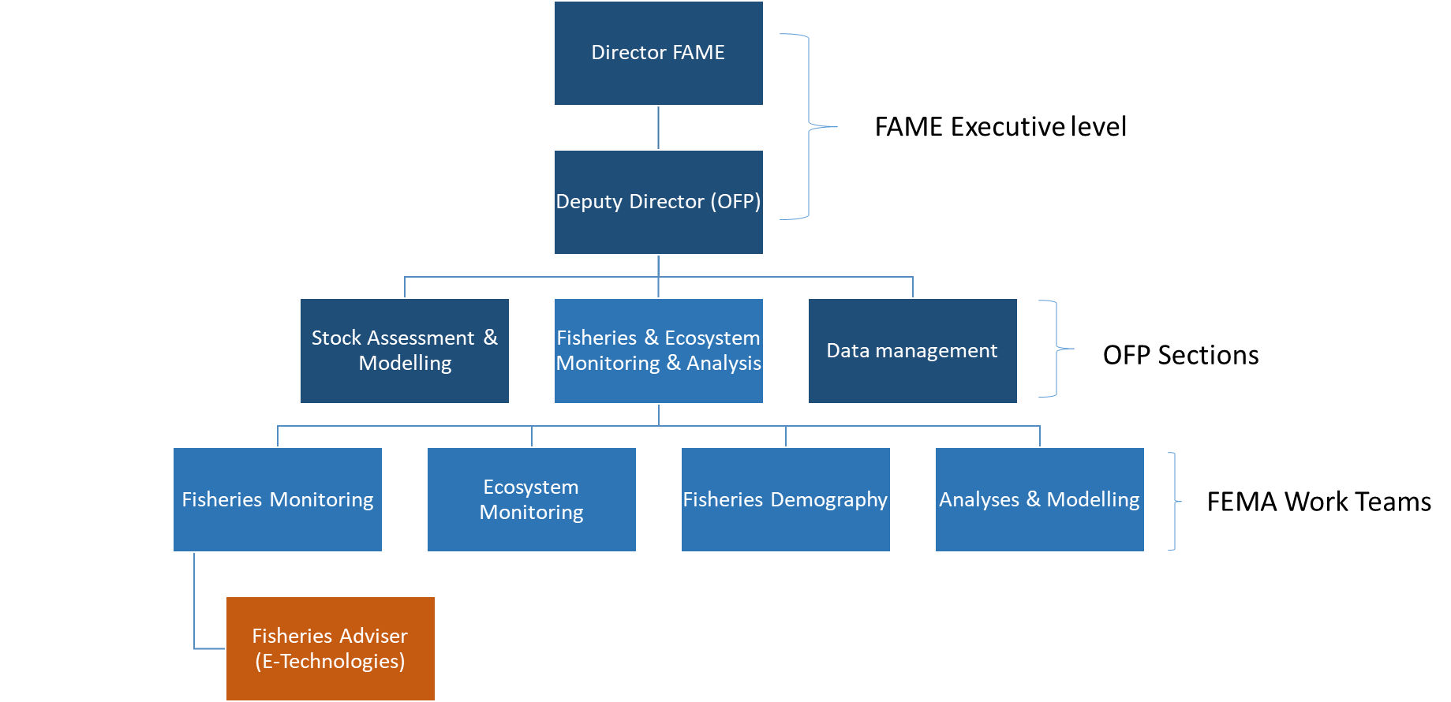

Key Result Areas (KRAs):

The position of Fisheries Adviser (E-Technologies) encompasses the following major functions or Key Result Areas:
- Leadership, administration and communication.
- Develop and implement proposals and work plans that facilitate the integration of E-Technology into regional fisheries monitoring and research activities, primarily focusing on the acquisition of data for science from at-sea monitoring to augment the output of observers, but also potentially including port-sampling activities, Pacific Marine Specimen Bank and Catch documentation and traceability activities.
- Transition E-Technology solutions into standard practice within fisheries monitoring programmes in the western and central Pacific Ocean, with member countries, regional and subregional partners.
- Builds capacity of SPC members in the relevant E-Technologies adopted for fisheries monitoring.

The performance requirements of the Key Result Areas are broadly described below

Jobholder is accountable for | Jobholder is successful when
- Leadership, administration and communication (15%)  - Contributes to annual work plans and work plan reports for the FEMA Section.  - Implements the SPC staff performance planning and management system for the Fisheries Monitoring E-technology Team  - Contributes to Programme, Divisional and Corporate publications, such as the Fisheries Newsletter, annual reports, Divisional reports for CRGA and Pacific Plan reports  - Liaises with other relevant FAME sections and SPC Divisions to ensure consistency in approaches, knowledge sharing and best practice | - Staff appraisals and performance planning for Section staff are completed on schedule  - Inputs to Programme, Divisional and Corporate publications are provided in a timely fashion.  - The Team contributes content for use by the Fisheries Information Section and FAME Communications Officer
- Transitioning E-Technology solutions into standard practices (50%)  - Consult and participate in national and regional processes to develop E-reporting and E-monitoring operational and data standards  - Consults with members regarding their fisheries monitoring needs and designs digital solutions (where appropriate) that contribute to meeting those needs,  - Formulate advice on E-reporting and E-monitoring issues as they relate to scientific data collections for SPC members, CROP agency partners and WCPFC  - Investigates potential of E-Technology Systems to support to SPC initiatives for enhanced data collection and curation.  - Oversees and contributes to the delivery of other E-Reporting and E-Monitoring activities and projects | - Regional standards for E-Technology covering scientific data for fisheries monitoring are established through the work of the SPC/FFA/PNAO Data Collection Committee and other regional/subregional processes, based on clear requirements.  - Demonstrated uptake of regionally adopted E-Technology standards for fisheries monitoring.  - Members and CROP agency partners are aware of the potential of new E-Technologies for acquiring scientific data through special projects to improve fisheries monitoring, including  - SPC has investigated and described the potential of new E-Technologies for acquiring scientific data  - Regional E-Reporting and E-Monitoring projects are executed according to work plans and budgets
- Implements integrated E-Technology systems (20%)  - Develop E-Technology solutions for scientific data collection in consultation with SPC members and CROP agency partners based on the agreed standards and requirements.  - Ensures quality assurance processes for the scientific data acquired through E-Technologies are implemented | - Standardised and verifiable E-Reporting and E-Monitoring systems are increasingly used for fisheries monitoring in the region, including  - E-Reporting systems supported by SPC have been widely and actively promoted throughout the region through regional and national meeting presentations and other means;  - E-Reporting systems supported by SPC are implemented [through the SPC Regional ER Coordinator], where requested;  - Assistance has been provided to member countries to implement E-Monitoring systems [through the SPC Regional ER Coordinator], where requested;  - Relationships have been established with third party E-Technology providers including regular liaison to ensure, for example, their systems adhere to the regional E-Technology SSPs;  - Relevant advice provided, and collaboration with Data Management team in the ongoing development of E-Reporting tools for the collection of scientific data through fisheries monitoring;  - E-Technology systems used in SPC member countries have regular reviews/systematic audits of fisheries science data collection.
- Capacity building of SPC members in fisheries monitoring (15%)  - Delivers regional vocational training in E-Technologies  - Reviews existing E-Technology platforms and undertakes capacity needs analysis | - Capacity building programmes are implemented according to annual work plans and budgets  - SPC members demonstrate increased capacity in the use of digital technologies.
The above performance requirements are provided as a guide only. The precise performance measures for this job will need further discussion between the jobholder and supervisor as part of the performance development process.

Most Challenging Duties Typically Undertaken (Complexity):

  - Managing a diverse work programme including high demands for support from other OFP sections, SPC members and other clients in funding-limited situations.
  - Analysis of current regional E-Technology systems with view to enhancement through innovation.
  - Innovative but pragmatic approach to new solutions for E-Technology for Fisheries Monitoring
  - Negotiating options for E-Technology solutions in a diverse and complex socio-economic environment.
  - Developing and implementing QA processes to ensure that monitor standards in E-Technologies are implemented and maintained.
  - Implements scalable E-Technologies across the diverse work programme of FAME.
  - Provision of concise and authoritative on-the-spot advice to members are national, sub-regional and regional meetings.
  - Organising and conducting training courses in a dynamic environment with limited resources.

Functional Relationships & Relationship Skills:

Key internal and/or external contacts | Nature of the contact most typical
External:  - SPC member fishery departments and the additional WCPFC member countries fisheries agencies  - Secretariat of the Western and Central Pacific Fisheries Commission  - Secretariat of the Forum Fisheries Agency  - PNA Office  - The South Pacific Regional Environment Programme  - E-Technology service providers  - Donors, including government, civil society, NGOs and industry  - National Fisheries E-Technology Coordinators and Officers | - Requests for assistance in fisheries monitoring and capacity building  - Liaising with senior officers regarding their E-Technology requirements, trials and implementation.  - Liaising with regional/sub-regional agencies in respect to the development of new or enhancing existing E-Technology standards and systems through the SPC/FFA/PNAO Data Collection Committee (for example), and relevant WCPFC processes.  - Development of work plans and budgets  - Development of reports, papers and proposals  - Liaising with government officials and NGOs on funding bids and reporting on existing projects and programmes
Internal:  - OFP Manager / Deputy Director, FAME  - OFP Oceanic Data Management, Ecosystem Monitoring and Analysis, and Stock Assessment and Modelling Sections  - Coastal Fisheries Programme  - Other SPC technical Divisions – PHD, GEM and SSD  - PCCOS  - OMD and SPL | - Collaboration with groups, new knowledge generation and provision of data & data products for incorporation into work undertaken across the Programme  - Management, direction and advice to team members  - Provision of advice on sources, content and quality of data  - Assistance in analyses to scientific staff  - Contribution to project management

Level of Delegation:

The position holder has no delegated responsibility as per SPC’s Instrument of Delegation.

Personal Specification:

This section is designed to capture the expertise required for the role at the 100% fully effective level. (This does not necessarily reflect what the current position holder has.) This may be a combination of knowledge / experience, qualifications or equivalent level of learning through experience or key skills, attributes or job specific competencies.

Qualifications

Essential: | Desirable:
- Masterdegree in fisheries science, fisheries management or related discipline | - A PhD degree in fisheries science or related discipline
Knowledge/Experience

Essential: | Desirable:
- A minimum of 7-8 years of demonstrated expertise in developing and progressing the monitoring requirements for scientific work and/or the management of fisheries.  - Demonstrated competencies in the application of E- technologies and/or fisheries intelligence systems for fisheries monitoring and scientific data collection.  - Well-developed and demonstrated facilitation and negotiation skills.  - Demonstrated experience in writing reports, meeting papers and proposals  - An excellent knowledge of e-reporting and e-monitoring tools and policies as they apply to tuna fisheries in the western and central Pacific Ocean  - Communication and inter-personal skills of a high order required to interact with colleagues from member countries, CROP agencies and industry specialists | - Considerable experience in tuna fisheries in the Western and Central Pacific  - Experience as an analyst of data derived from E-technologies  - Experience in the application of fisheries monitoring in pelagic fisheries  - If anglophone, a working knowledge of French. If francophone, a working knowledge of English.

Key Skills/Attributes/Job Specific Competencies

The following levels would typically be expected for the 100% fully effective level:

Expert level | - Knowledge of tuna fishery monitoring and tuna data quality systems.  - Project development and management in an international context.  - Aptitude for the provision of high-quality service and advice
Advanced level | - Fisheries monitoring techniques (data collection systems) related to scientific data requirements  - WCPO Tuna Fisheries  - E-Technology approaches for monitoring fisheries  - Oral and written communication skills  - Staff supervisory skills (internal)  - Organizational skills  - Communication skills  - High-level interpersonal skills (internal and external)  - A flexible approach and a willingness to assist with a variety of tasks, as required.
Working knowledge | - Tuna fishing operations  - WCPFC key documents and purpose  - Technical report writing  - Auditing concepts  - Ability to design and conduct training courses  - Ability to deal with confidential information in a professional manner.  - English and French language
Awareness | - Fisheries stock assessment methods  - Tuna biology  - Fisheries management principles  - Tuna Fisheries in other oceans  - SPC policies relating to recruitment, gender, harassment, and others

Key Behaviours

All employees are measured against the following Key Behaviours as part of Performance Development:

  - Change and Innovation
  - Interpersonal Skills
  - Teamwork
  - Promotion of Equity and Equality
  - Judgement
  - Building Individual Capacity

Personal Attributes

  - High level of professional integrity and ethics
  - Friendly demeanor
  - Demonstrated high level commitment to customer service

Change to Job Description:

From time to time it may be necessary to consider changes in the job description in response to the changing nature of the work environment - including technological requirements or statutory changes. Such change may be initiated as necessary by SPC. This Job Description may also be reviewed as part of the preparation for performance planning for the annual performance cycle.

