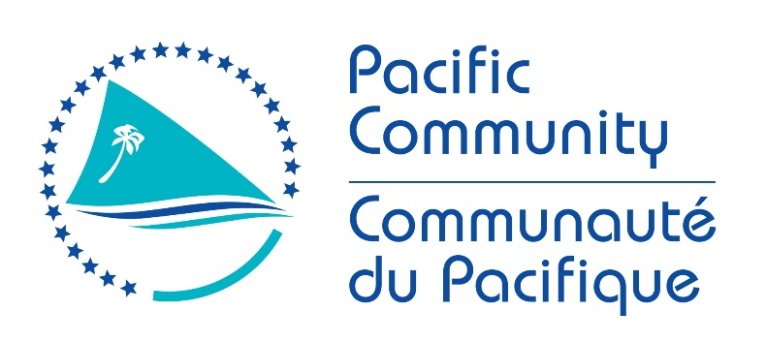

JOB DESCRIPTION

Job Title: | PACIFIC ISLAND FISHERIES PROFESSIONAL (Coastal Fisheries Science)
Division/Programme  and Section/Project (if any): | FAME - Coastal Fisheries Programme - Coastal Fisheries Science, Management and Livelihoods section – Science unit - PEUMP project
Location: | Noumea
Reporting to: | Senior Coastal Fisheries Scientist
Number of Direct Reports: | No Direct reports
Purpose of Role: | To support the Coastal Fisheries Scientists, including Fisheries Managers, with providing support and advice to governments, stakeholders and the private sector in planning and implementing coastal fisheries science and management activities, focusing on coastal finfish and/or invertebrate resources and their supporting habitats.
Date: | October 2020

Organizational Context and Organization Chart

Key Result Areas (KRAs):

The position of Pacific Island Fisheries Professional (Coastal Fisheries Science) encompasses the following major functions or Key Result Areas:
- Assess the status of coastal living marine resources including their supporting habitats and the social and demographic aspects of coastal and community fisheries to inform management.
- Practical assistance to members in designing and targeting appropriate awareness raising and educational information.
- Section administration and communication

The performance requirements of the Key Result Areas are broadly described below

Jobholder is accountable for | Jobholder is successful when
Assess the status of coastal living marine resources including their supporting habitats and the social and demographic aspects of costal and community fisheries to inform management  - Assists with conducting surveys of finfish and/or invertebrates and their supporting habitats across Pacific Island Countries (PICs) and Timor Leste, including entry of data collected into national/regional databases.  - Assists with conducting fisheries socioeconomic surveys across PICs, including entry of data collected into national/regional databases.  - Assists with conducting virtual or face to face training of local staff in survey methodologies for finfish, invertebrate resources, associated habitats and fisheries socioeconomics.  - Assists with the analysis of data collected and the production of reports.  - Assists with turning scientific advice into management recommendations for both community-based and national management approaches.  - Assists with the development or review of coastal fisheries management plans. | - partakes in country-specific monitoring programmes or reviews of survey information and performs data entry into regional and national databases for reef finfish, invertebrate fisheries, associated habitats and fisheries socioeconomics (noting COVID-19 restrictions)  - local staff are adequately trained to undertake reef finfish and invertebrate surveys and data entry into regional and national databases.  - results of data analysis are provided through assessment reports and management advice.
Practical assistance to members in the designing and targeting of appropriate awareness raising and educational information  - In collaboration with the Fisheries Information Unit and other components of the PEUMP programme, assists with developing materials such as training manuals, guidelines, information sheets and other educational or awareness materials.  - Works with other CFP staff to contribute to the development of on-line learning tools for remote access by member countries | - Manuals, guidelines and information materials are produced in line with the work plan and country needs.  - Contribute coastal fisheries sciences related von-line learning tools
Section administration and communication  - Assists the Adviser and Senior Scientist, to develop the annual work plan and reports for the Section.  - Maintains up to date corporate and administrative procedures for all activities undertaken.  - Acquits any cash advances that are used for fieldwork with receipts for all expenditure.  - Contributes where applicable to Programme, Divisional and Corporate publications, such as Fisheries Newsletters and PEUMP programme articles and progress reports.  - Produces reports for all activities undertaken in the appropriate format for the activity including technical reports and trip reports, and input to funding proposals, donor reports. | - Annual work plans and reports for the Section are produced.  - All of the operations and activities undertaken are fully documented, funds acquitted with receipts, and all administrative tasks completed within the set deadline.  - Input or articles are provided for all Programme and Divisional publications within the set deadlines.  - Trip reports are produced within two weeks of completing an activity.
The above performance requirements are provided as a guide only. The precise performance measures for this job will need further discussion between the employee and supervisor as part of the performance development process.

Most Challenging Duties Typically Undertaken (Complexity):

- Assisting Coastal Fisheries Scientists with undertaking surveys with local staff in-country.
- Assisting the Senior and Coastal Fisheries Scientists with implementing functional monitoring programmes in country.
- Assisting the Senior Scientist and Coastal Fisheries Scientists in providing training in monitoring and collection and management of data to local staff, with local staff being competent in all areas after the training.
- Assisting the Senior Scientist and Coastal Fisheries Scientists in development of online training modules that are technically and culturally relevant.
- Assisting the Senior Scientist and Fisheries Managers in providing sound scientific advice based on the best available data for management purposes.
- Assisting Coastal Fisheries Scientists to develop management recommendations from scientific advice and compile this in briefing notes or reports to governments.

Functional Relationships & Relationship Skills:

Key internal and/or external contacts | Nature of the contact most typical
External:  - Government technical staff, NGOs, stakeholders, private sector, CROP agencies,  - Technical partners  Consultants | - Negotiating, gaining cooperation, reporting  - Liaising, gaining cooperation, reporting  - Collaborating, assisting, advising
Internal  - Director, Deputy Director, other staff in FAME including PAs  - Staff from other sections, Finance, Human Resources, Publications, Registry etc. | - Explaining, gaining cooperation, resolving minor conflicts, reporting  - Liaising, collaborating, resolving minor conflicts

Level of Delegation:

The position holder:
- Routine expenditure budget: None
- Budget sign off Authority without requiring approval from direct supervisor: None

Personal Specification:

This section is designed to capture the expertise required for the role at the 100% fully effective level. (This does not necessarily reflect what the current position holder has.) This may be a combination of knowledge / experience, qualifications or equivalent level of learning through experience or key skills, attributes or job specific competencies.

Qualifications

Essential: | Desirable:
- A recognised degree in a discipline relevant to coastal fisheries assessments (finfish and/or invertebrates), or related field.  - Current open-water SCUBA diving certificate and medically fit and able to dive in a range of environments. | - Qualification in another relevant field (e.g. fisheries management or marine affairs).

Knowledge/Experience

Essential: | Desirable:
- At least two years’ direct relevant experience in Pacific Islands or Timor Leste coastal fisheries, particularly applied field research for coastal finfish and/or invertebrates  - Demonstrated experience in undertaking surveys for coastal finfish and/or invertebrates using a range of methodologies  - Understanding of current Pacific Island regional coastal fisheries management and science issues, and experience of working with gender issues relating to fisheries  - Excellent communication skills (oral and written) in English  - Excellent interpersonal skills, ability to work in a team as well as undertake unsupervised work, and communicate with people from various ethnic, cultural and educational backgrounds  - Strong PC based computer skills (Microsoft Word, Excel, PowerPoint and Outlook) with knowledge of software programmes for data entry and analysis  - Willingness to travel and undertake overseas assignments in SPC member countries, sometimes under difficult physical conditions. | - Prior experience or involvement with socioeconomic survey work  - Experience in developing and implementing fishery management plans  - Working knowledge of French  - Willingness to learn new skills such as use of R software for analysis and reporting.

Key Skills/Attributes/Job Specific Competencies

The following levels would typically be expected for the 100% fully effective level:

Expert level
Advanced level | - Scientific sampling and monitoring methodologies for coastal  - Management options for coastal fisheries  - resources
Working knowledge | - Data analysis and interpretation of results  - Social sampling and monitoring methodologies for coastal and community fisheries  - Crosscutting issues such as food security and climate change
Awareness | - Broader fisheries management and development issues  - Relevant social and economic issues in the Pacific  - Gender issues and human rights-based approached to coastal fisheries management, with ideas about how to increase the participation of women and youth in delivering PEUMP programme outcomes.

Key Behaviours

All employees are measured against the following Key Behaviours as part of Performance Development:
- Demonstrating Personal Accountability
- Applying Expertise
- Working Together
- Creating Value for Customers
- Communicating Effectively
- Building Individual Capacity

Personal Attributes

- Physically fit
- Ability to work in a group
- Clear and effective communicator
- Ability to think on and off your feet
- Ability to sum up the situation and make decisions quickly if required, especially in the field.

Change to Job Description:

From time to time it may be necessary to consider changes in the job description in response to the changing nature of the work environment - including technological requirements or statutory changes. Such change may be initiated as necessary by SPC. This Job Description may also be reviewed as part of the preparation for performance planning for the annual performance cycle.

Approved:

Manager/Supervisor Date

Employee

