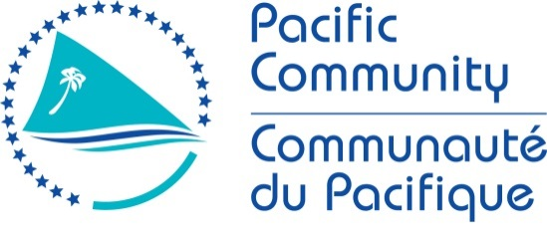

JOB DESCRIPTION

Job Title: | Director of Resource Mobilisation and Integration
Work Unit: | Office of the Deputy Director-General, Operations and Integration
Responsible To: | Deputy Director-General, Operations and Integration
Responsible for | Two direct reports
Job Purpose: | The Director of Resource Mobilisation and Integration leads the Resource Mobilisation and Integration functions in the Office of the Deputy Director-General, Operations and Integration (DDG O&I).  As well as direct reports, this position will be responsible for convening a matrixed team to manage integrated and country programming and resource mobilisation, aligned with the SPC strategic plan.  Reporting to the DDG O&I, the position is accountable for coordinating existing and generating new income to support implementation of SPC’s strategic plan and programmes, as well as facilitating the integration of SPC’s programming and corporate functions to better meet development and organisational objectives.  The position-holder is responsible for overseeing SPC’s Resource Mobilisation Plan and leading and managing the Resource Mobilization Team. Over the next decade, this will entail significantly growing annual income and overseeing the transition from a resource mobilisation model that is highly dependent on a small number of Members and external donors to a more diverse funding portfolio that is strategically aligned.  In addition, the position-holder is responsible for supporting and contributing to strategic leadership, coordination and facilitation of major initiatives to help SPC achieve high quality integrated and country programmes, drawing on synergies between SPC’s communities of practice and aligned with the organisation’s strategic priorities and Member country needs.  As a member of the SPC senior leadership team, the Director of Resource Mobilisation and Integration contributes to cross-organisational leadership and defining and implementing broader organisational strategies.
Date: | January 2021

Organisation Context: DDG Operations and Integration

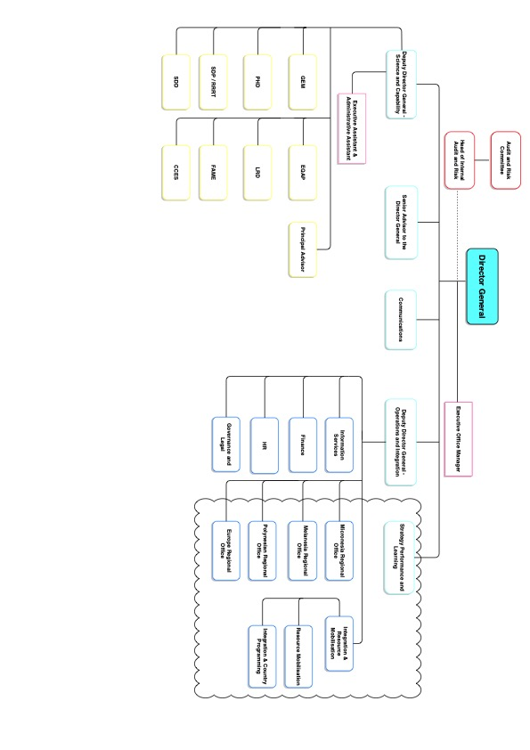

Key Result Areas:

The position of Director of Integration and Resource Mobilisation is responsible for facilitating greater integration of its capabilities and programmes for development impact, together with leading and coordinating SPC’s resource mobilization. This new function will work under the authority and in close collaboration with the DDG O&I, achieving the following following major functions or Key Result Areas in collaboration with teams across the organisation:

Integrated Resource Mobilisation
- Designing, developing, implementing and monitoring SPC’s integrated Resource Mobilisation Strategy for the priority areas identified in the SPC Strategic Plan, aimed at securing, diversifying, increasing and sustaining SPC’s funding base, including: opportunities and risks related to diverse resource mobilisation sources, innovative fundraising approaches, developing fundraising strategies that support new internal and external partnerships and other outreach strategies that will strengthen the organisation’s external positioning.
- Formulating global resource mobilisation objectives and funding targets for different donor segments (i.e., traditional government donors; new government donors; development actors; private sector actors including individuals, foundations and companies; new financing models) and establishing related action plans.
- Support to Division Directors ensuring that all relevant resource mobilization activities are developed, coordinated and implemented in the most efficient and effective manner in line with quality management standards and the results-based approach.
- Design and implement a strategic, results-oriented and coordinated approach to the mobilization of significant additional resources from traditional and non-traditional sources such as private sector organizations, foundations

Leadership and Integration
- Leading and coordinating overall fundraising efforts, ensuring the implementation of an integrated approach to resource mobilisation through the definition and application of clear roles and responsibilities across the organisation.
- Coordinating with the Strategy, Performance and Learning Unit (as methodological leads), the Directors of SPC Regional Office network, the SLT and heads of integrated programmes to develop appropriate governance and for country and integrated programmes, and build internal communities of practice around integration issues.
- Advising on and supporting opportunities to develop and implement integrated and country programmes aligned with SPC’s strategic objectives and needs expressed by Members.
- Actively promoting SPC-wide principles for resource mobilisation, integration and country programming and developing concrete approaches to support these efforts within the Secretariat, with Members, donors and other partners. This includes assessing the opportunities and risks of income-related decisions and putting in place quality standards to guide fundraising, investment, and partnership and proposal development and implementation.
- Promoting and ensuring the inclusion of SPC’s ‘fundraising identity' as part of its broader institutional brand, working closely with key internal stakeholders including other expert and management functions (executive, SLT, divisions, communications, strategy performance and learning, OMD) to leverage information and coordinate initiatives for securing the requisite political and financial support for SPC’s work.
- Implementing a financial, quality and accountability framework to support fundraising decisions and track related returns, ensuring the requisite transparency in the management of funds.
- Advising and supporting SPC leadership (Chair of Conference and CRGA, Member representatives, Executive, SLT etc) to leverage their support in key donor relationship development and management.
- Analysing development and funding policy trends with the aim of sharing intelligence and connecting the dots between donor interests and SPC’s mandate and objectives and evaluating SPC’s performance vis-à-vis other similar organisations (including CROP agencies).
- Supporting the Directors of OMD to develop more integrated service platforms that enable SPC’s integrated and country programme approaches.
- Coordinating and facilitating organisation-wide efforts to enhance integrated programming of SPC’s development activities and technical assistance, including current integrated and country programmes, and where appropriate identifying, developing and implementing new initiatives.
- Providing strategic advice and high-quality analysis to the Executive, SLT and, where relevant, to SPC’s governing bodies, on all aspects of resource mobilisation, fundraising and other outreach strategies, including assessments of different fundraising approaches and funding opportunities related to SPC strategic objectives, the Sustainable Development Goals (SDG) agenda and other regional and international processes and events.
- Providing proactive guidance and advice to the Executive as well as other senior managers across SPC regarding donor priorities and concerns, through targeted meetings and briefings; identifying cutting edge and innovative resource mobilisation and related advocacy tools and processes and mainstreaming their use in SPC.
- Establishing, maintaining and nurturing close relationships with SPC’s current and potential partners, including governments, public and private institutions, governmental agencies, development partners, civil society, foundations, national committees, businesses, etc
- Guiding, advising and supporting cross-organisational efforts related to resource mobilisation, integrated and country programming, including divisions, SPC’s regional offices, and the Communications team.
- In collaboration with the Communications team and the executive, contributing to the regional and global multi-media communications strategy, advocacy and specific campaign messages.
- Promoting a client-focused approach to problem-solving, providing sound resource mobilisation and development programming solutions to colleagues across SPC.
- Developing and maintaining constructive and effective working relationships across SPC in support of resource mobilisation and integration; working closely with the Department of Finance to provide accurate and timely updates on both income and cash flow and with the Strategy, Performance and Learning team to ensure joint cooperation on integrated and country programming, harmonized reporting and indicators.

Stakeholder engagement
- Participating in and representing SPC in international, regional and bilateral donor meetings, and stakeholder as well as other outreach functions, as requested.
- Facilitating and contributing to the preparation of donor campaigns and, in liaison with SPL, reports and present their contents to relevant audiences.
- Participating in and representing SPC in engagement with Members and relevant partners on integrated and country programming.

Team leadership and management
- Building, supervising and managing a team of skilled professionals
- Coordinating with and supporting the broader network of resource mobilisation and integration capabilities across SPC
- Overseeing the preparation and implementation of the Resource Mobilisation and Integration work plans, determining priorities in consultation with key stakeholders, and allocating resources for the completion of outputs and their timely delivery.
- Regularly assessing the performance of SPC’s Resource Mobilisation and Integration functions and recommending actions to enhance their relevance.

The requirements in the above Key Result Areas are broadly identified below.

Job holder is accountable for | Jobholder is successful when
Integrated resource mobilisation | - SPC’s multi-year resource mobilisation strategy for the implementation of SPC’s Strategic Plan is designed, developed consultatively and implemented successfully  - SPC’s integrated and country programming processes are of high quality, mainstreamed and resourced.  - Quality standards and tools for resource mobilisation and programme development are in place.  - SPC-wide understanding of the resource mobilisation and integration functions’ role and added-value is increased.
Leadership and integration | - Quantitative targets for fundraising are set and met (multi-year and annual), with new funding aligned with SPC strategic and Member prioririties.  - Positive relationships are developed and maintained with all relevant key internal and external stakeholders  - Opportunities for synergies and new initiatives are identified and acted upon within the job-holder’s portfolio  - SPC benefits from regular analysis of development and funding policy trends to inform donor management and decision making  - Development and coordination of integrated and country programming is centralised, in collaboration with SPL.  - SPC’s corporate areas receive strategic advice to move toward platforms that support integrated approaches.  - Proactive and positive contributions are made to the SLT and other cross-organisational initiatives  - Excellent working relationships with the Executive, SLT, divisions and OMD are built and maintained  - Timely and comprehensive advice is provided all aspects of resource mobilisation, fundraising and other outreach strategies  - Peer and client relationships with internal stakeholders are appropriately managed to facilitate cross-organisation collaboration in support of the resource mobilisation and integration functions, including through the use of networks and communities of practice  - The resource mobilisation and integration functions operate with a clear customer-service focus and approach
Stakeholder engagement | - SPC’s network of donors, its brand and partnerships are maintained and broadened through positive relationships and targeted donor campaigns  - Country engagement is consistent and standardised to develop country programmes aligned with member needs and SPC’s strategic goals  - Stakeholder feedback (Members, donors, partners) is consistently positive
Team leadership and management | - High quality talent is recruited and retained within the portfolio  - The network of integration and resource management functions within SPC is coordinated and supported.  - Annual workplans are prepared and successfully implemented  - Performance of individuals and teams is consistently monitored and opportunities for improvement are identified and acted on  - A positive working environment is created and nurtured, promoting a culture of transparency, empowerment and mutual respect

Note

The above performance standards are provided as a guide only. The accurate performance measures for this position will need further discussion between the jobholder and supervisor as part of the performance development process.

Work Complexity

Most challenging duties typically undertaken:
- Strengthening disparate capabilities and establishing a central function across SPC and multiple locations
- Influencing the Executive and SLT on issues of resource mobilisation, integrated and country programming
- Co-developing a long-term strategy to ensure that fundraising, and integrated/country programming functions and capabilities across the organisation are coherent and operate effectively and efficiently
- Implementing organisational change
- Management of high workload with limited resources
- Engaging with donor and SPC members
- Fostering a professional resource mobilisation function in SPC
- Developing robust, positive relationships with key stakeholders

K

Functional Relationships & Relationship Skills

Key internal and/or external contacts | Nature of the contact most typical
Internal
- Internal  - Director-General, Deputy Director-General Operations & Integration and Deputy Director-General Science & Capability  - Senior Leadership Team and thematic programme leads  - Strategy, Performance and Learning team  - SPC regional offices  - Integrated programming teams and working groups working across Divisions  - All divisions and programmes  - Other support services  - Staff | - Providing strategic advice and intelligence  - Consulting and influencing  - Coordination, facilitation and support for resource mobilisation, integrated and country programming activities  - Managing peer and client relationships and expectations  - Management and supervision
External
- External  - Member State and Territory representatives  - Contacts in donor agencies, including high-level philanthropic leaders and private sector donors (individuals, foundations and corporations)  - Counterparts in other international agencies, including CROP  - Contractors  - Other public and private partners | - Liaison with Member representatives on governing bodies and/or in international, regional or bilateral contexts  - Participation in negotiations, consultations and discussions with donors, Members and other stakeholders  - Participation, when requested by the DG or DDG Operations and Integration, in interagency consultations

Level of Delegation

To carry out the functions and responsibilities as authorised under delegation from the Director-General and outlined in the SPC Instrument of Delegations and Authorisations.

Person Specification

Qualifications

Essential: | Desirable:
- An advanced university degree (Master’s degree or equivalent) in finance, business or public administration, political/social sciences, international relations, international development,
- Communications or other relevant field

Knowledge / Experience
Essential: | Desirable:
- At least 15 years of progressively responsible and relevant professional experience and partnership responsibilities.  - A proven (multi-year) track record of significant success in business development and resource mobilisation and an established network of donor agencies and contacts.  - Experience in developing, managing and/or resource mobilising for long-term or multidisciplinary programmes of work in an international development, government, or academic context.  - Superior analytical, quantitative, and writing skills with a demonstrated ability to communicate resource mobilisation needs and themes, business analysis, and market assessment and matching donors interests to organisational values and stakeholder impact. .  - Demonstrated experience in identifying strategic opportunities and risks, designing and implementing strategies and accompanying organisational change.  - Sound knowledge of the international development landscape and programme development and delivery at international, regional and/or country level  - Demonstrated cultural sensitivity and awareness, and the ability to effectively work with stakeholders and team members from different cultural backgrounds.  - Strong project management skills, particularly the ability to work and deliver projects on-time while operating independently and under pressure.  - English and French are the working languages of the Pacific Community. For the post advertised, fluency in either English or French (both oral and written) is required with an excellent command of the other working language highly desirable. | - At least 7 years in a senior position in an international or intergovernmental organisation.  - Good knowledge of and experience in the Pacific region.  - Proven experience of the specific needs of an organisation working in the international development context.  - Knowledge of other languages.

Key Skills /Attributes / Job Specific Competencies

The following levels would typically be expected for the 100% fully effective level:

Expert level | - Donor relations and management  - Leadership  - Strategic awareness and planning  - Decision making and problem solving  - Political awareness  - Communication and representation skills  - Proposal development and the establishment of review and quality assurance processes.  - Ability to understand and explain business models and financial strategy  - Ability to build effective partnerships and lead/influence multidisciplinary teams within large organisations or bureaucracies
Advanced level | - Development programming and country engagement  - Cross-cultural skills and ability to work with stakeholders and team members from different cultural backgrounds  - Collaboration and consultation  - Negotiation and influencing skills  - Change management
Working Knowledge | - Computer skills  - Ability to travel

Key Behaviours

All employees are measured against the following Key Behaviours as part of Performance Development:

- Change and Innovation
- Interpersonal Skills
- Teamwork
- Promotion of Equity and Equality
- Judgement
- Building Individual Capacity

Personal Attributes

- Adaptability
- Good planning and organisation skills
- Result oriented
- Honesty
- Good sense of commitment and responsibility
- Customer focus
- Working experience in dealing with colleagues and stakeholders from different backgrounds and cultures

Change to Job Description

From time to time it may be necessary to consider changes in the job description in response to the changing nature of our work environment – including technological requirements or statutory changes. This Job Description may be reviewed as part of the preparation for performance planning for the annual performance cycle.

